**SM507 andrology book**

**Written by:**

**Prof. sherif salah Azab**

**The Penis**

**- Definition**: Penis is the male organ of copulation.

**- Descriptionis**t is described as having a ***root*** (or attached portion) and a ***shaft*** (or free portion).

* The root is formed of ***3*** parts; ***two crura*** (right and left) and ***bulb*** of penis, ***(fig.1)***
* The shaft is formed of ***3*** columns of erectile tissue; ***two corpora cavernosa*** (right and left) and a median ***corpus spongiosum***.

**- The shaft of the penis: -**

**A- The two corpora cavernosa: - *(fig.1,3)***

- They lie dorsally side by side in the shaft of penis.

- Each is firmly surrounded by fibrous tissue called tunica albuginea which also sends a median septum between the two.

***- Followed distally***, the corpora cavernosa end in pointed projections within the cap-like ***glans penis*** of corpus spongiosum

***- Followed proximally*** the two corpora cavernosa diverge from each other and each passes posterolaterally to continue as ***the crus penis***, which becomes firmly attached to the ischiopubic ramus.

- The corpora cavernosa contains many ***irregular cavernous spaces*** which become filled by blood during erection.

**B- The corpus spongiosum *(fig.1,3)***

- It is median and lies in the ventral surface of the two corpora cavernosa.

- It is also surrounded by a separate sheath of tunica albuginea

***- Followed distally***, it forms glans penis which fits over the distal ends of the corpora cavernosa.

***- Followed proximally***. it expands into a swelling called ***bulb of the penis*** which is attached to the inferior surface of the perineal membrane

- The corpus spongiosum is traversed by the penile part of the urethra. It also contains cavernous tissue capable of erection.

**- The skin of the penis*: (fig.2****)*

- It is smooth and thin over the erect penis but is wrinkled over the flaccid penis.

***- Followed distally***, the skin forms a loose fold called the ***prepuce*** which covers the glans.

***- Followed proximally***, the penile skin is continuous with skin of the scrotum.

**- Arteries of the penis: -**

All are branches of internal pudendal artery and all are paired (right and left).

1. ***Dorsal artery*** of the penis supplies the skin, fascia, and glans ***(fig.2)***
2. ***Deep artery*** of the penis supplies the corpus cavernosum (with convoluted helicine arteries)
3. ***Artery of the bulb*** supplies the corpus spongiosum and glans penis.

**- Venous drainage*: (fig.2****)*

By **2** dorsal veins which are superficial and deep.

1. ***Superficial dorsal vein*** divides into right and left, each end in the corresponding superficial external pudendal vein.
2. ***Deep dorsal vein*** of the penis passes below symphysis pubis to terminate in prostatic venous plexus.

**- Lymph drainage: →** superficial inguinal lymph node

**- Nerves of the penis:**

1. ***Dorsal nerve of the penis*** (sensory), is a branch of pudendal nerve, runs ***lateral*** to the dorsal artery of the penis.
2. ***Cavernous nerves*** (autonomic) arise from the inferior hypogastric plexus (see pelvis). Parasympathetic fibers (S2,3,4) produce vasodilatation & erection of penis

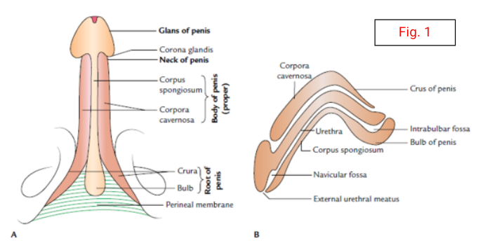

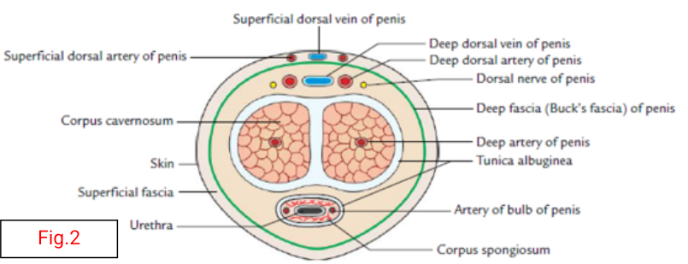

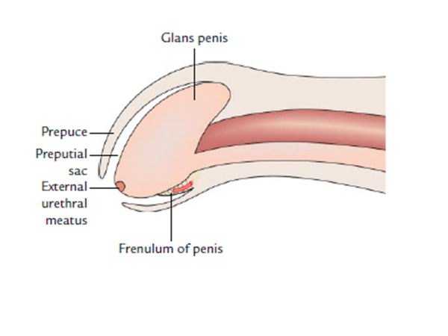

Fig-3

|  |
| --- |
| **PENIS AND URETHRA** |

***PEYRONIE’S DISEASE***

Defenition :

* Inflammatory process involving tunica albuginea of corpora cavernosa resulting in fibrotic plaque
* Commonly on dorsal surface resulting in upward curvature of erect penis due to scar tissue ––> pain on erection or sexual intercourse
* D.D chordee = is a congenital anomaly resulting from abnormal development of penis
* with ventral bend
* D.D In children, chordee associated with hypospadias (1/300)

Cl.Picture : short , curved penis, palpable mass on the shaft , painful erection ,

erectile dysfunction, difficult painful intercourse

Diagnosis: clinical examination, palpable scar fibrous tissue (size, site)

Penile ultrasound (the most important diagnostic tool)

Treatment

* Massage and traction stretching theapy
* Pain medication , Ibuprofen
* **topical vitamin E cream + aminobenzoic acid**
* **Injection collagenase ( FDA approved )**
* **surgical excision of plaque, prosthesis for erectile dysfunction**

**PRIAPISM**

Definition

* Prolonged and persistent penile erection usually painful, that is unrelated to sexual interest or stimulation and lasts longer than 4 hours)

Types: 1- Ischemic priapism (emergency)

Ischemic priapism results from occlusion of the venous outflow of the corpora cavernosa; this prevents arterial inflow and leads to a cascade of tissue ischemia and damage, usually painful

Causes:

* 60% idiopathic
* intracorporal drug injection (papaverine, phentolamine, PGE1)
* Sickle cell disease

Diagnosis: Penile Doppler, Penile blood gas measurement ( Black blood, deprived of O2)

Treatment:

corporal aspiration through a 21-gauge needle, subsequent injection of a

diluted α-adrenergic (phenylephrine)

percutaneous distal shunt procedure between the corpora and the glans

2- Nonischemic priapism

* Result of trauma to the perineum or penis
* vascular injury to the cavernosal artery exacerbated by erection
* fistula forms between the artery and the sinusoidal spaces
* persistent, painless penile tumescence. venous drainage is preserved, no ischemic

Treatment: Observation and penile compression

selective arterial embolization, and surgical intervention

3- stuttering priapism

intermittence episodes which last several hours, leads up to the onset of ischaemic

priapism , linked to Sickle cell disease and blood diseases

**Complication**

* **Erectile dysfunction due to corporal fibrosis if treatment delayed (50%)**

Hematospermia (Hemospermia)

Def:

Hematospermia is: as the macroscopic appearance of blood in semen or ejaculate. and considered a benign symptom, painless that always resolves spontaneously, and is rarely associated with significant urological pathology and is most often considered to be idiopathic in nature.

Causes of the Hematospermia

1. Infl**ammatory/infection**

Prostatitis

Urethritis,

Epididymo–orchitis

Seminal vesiculitis

Genital-urinary tuberculosis (Mycobacterium spp.)

Sexually transmitted disease: gonorrhoea syphilis, (Chlamydiatrachomatis

herpes genitalis (herpes simplex virus, Ureaplasma urealyticum,

Mycoplasma spp., aids (HIV),

(herpes virus/HPV, cytomegalovirus

Urinary tract infection in general:

2- Obstruction/congenital

Prostate calcification

Benign prostate hypertrophy

Seminal vesicle calculi/dilatation/obstruction

Ejaculatory duct calculi/dilatation/obstruction

1. Tumors

Benign

Condylomata acuminata of urethra

Papillary adenoma of prostate or urethra

Malignant

Prostate adenocarcinoma

Carcinoma of bladder or urethra

Seminal vesicle carcinoma

1. Vascular

Prostate varices

Excessive sex or masturbation

1. Trauma/iatrogenic

Prostate biopsy

Trauma of perineum, genitalia, pelvic

1. Systemic

Hypertension

Bleeding disorders

Hemophilia purpurea, von Willebrand disease

1. Idiopathi

Investigation, Differential Diagnosis,

* Medical/surgical history >>> Differential diagnosis
* Physical examination >> Probable cause finding
* Investigations:
* Urine analysis/urine culture >> Urinary tract infection
* Semen culture >> Infection of semen
* Complete blood count >> Bleeding disease
* Urethrocystoscopy >> Strictures/stones/prostate varices
* Transrectal ultrasonography >> Cysts/calcification/ pathological structure
* Magnetic resonance imaging >> Morphology/pathological structure

Treatment : According the cause

**Erectile dysfunction**

**Mechanism of erection**: Erection is either reflexogenic or psychogenic; penile erection requires 4 physiological events:

1. Intact innervation. 2. Intact arterial supply. 3. Responsive corporeal smooth muscles. 4. Intact veno-occlusive mechanism.

**Erectile Dysfunction (ED)**: It is the inability to obtain or maintain erection of sufficient quality for satisfactory penetration.

ED (Impotence) is either organic or psychogenic 50% to 80% of all impotent patient belong to the organic group. Only 20% to 30% is purely psychogenic. Psychogenic causes are more common in young patients, while organic causes are more common in old age patients.

**Causes of organic impotence**

**I) Predisposing (risk) factors. II) Endocrinal causes. Ill) Vascular causes: arterial, venous, sinusoidal. IV) Neurogenic causes.**

**I) Predisposing risk factors for impotence**

1. Hypertension: Hypertension and atherosclerosis will decrease the arterial inflow to the penis leading to impotence. Sexual dysfunction in hypertensive patients is more likely to be due to antihypertensive drugs.

2. Diabetes mellitus: More than 50% of diabetic men develop erectile dysfunction during the course of the disease. The incidence of erectile dysfunction is 2-5 times higher in diabetics than in normal men. Impotence in diabetics may be: Initial symptom in undiscovered DM, it may occur in the course of the disease, or it may be temporary in uncontrolled diabetes.

Pathophysiology of erectile dysfunction in diabetes mellitus:

a) Endocrinal dysfunction. b) Diabetic angiopathy.c) Autonomic neuropathy. d) Psychogenic.

3. Renal failure: 20% to 50% of patients with renal failure complain of erectile dysfunction.The mechanism of

ED in patients with chronic renal failure may be:

i) Hypertension or antihypertensive therapy.

ii) Endocrinal malfunction (hyperprolactinemia and low testosterone).

iii) Uremic neuropathy.

4. Smoking: Nicotine has vasoconstrictive effect on blood vessels impairing-blood flow to the penis which will impair erection.

5. Drugs: Psychotropic drugs, antihypertensive drugs, cardiac drugs, antihistamines, H2 receptor antagonist and antiandrogens.

6. Alcohol: may initially increase libido, but it will impair erection, ejaculation and orgasm.

**II) Endocrinal causes of erectile dysfunction**

***A) Androgens and sexual response***

The role of hormones in human sexual response is not accurately defined, in men androgens are necessary for sexual desire and ejaculation, but erection and orgasm are not androgen dependent. Androgens have stimulatory effect on the sexual desire in women.

***B) Prolactin***: Men with hyperprolactinemia experience loss of libido and impotence. Hyperprolactiemia is associated with decrease of serum testosterone level.

**Ill) Vasculogenic causes of erectile dysfunction**

1. ***Arterial insufficiency:***
2. Defective blood supply to the corpora cavernosa is a common cause of impotence: arterial insufficiency is commonly seen in cases of arterial dyspepsia, arteriosclerosis, arterial spasm, tumors, trauma and stricture. Patients with mild to moderate arterial insufficiency will need longer time to initiate erection while patients with severe arterial insufficiency can not initiate erection.

***B) Venogenic causes:***

A careful balance between blood flow into and out of the erectile bodies is essential in providing erection. Outflow regulation is dependant on the integrity of corporeal veno-occlusive mechanism.

***C) Sinusoidal causes:*** Ultrastructural degenerative changes of smooth muscle cells of the corpus cavernosum or depletion of neurotransmitters will result in ED.

**IV) Neurogenic causes of erectile dysfunction**

a) Cerebral disorders: Cerebral lesions that affect the hypothalamus, thalamus or limbic system (brain surgery, trauma, tumors or inflammation) may result in impairment of erection, ejaculation or penile sensation.

b) Spinal cord lesions: The effect on sexual function will depend on the site of lesion. c) Peripheral lesion: most peripheral lesions are either traumatic or iatrogenic.

**Causes of psychogenic erectile dysfunction**

1. Fear of loss of control during the sexual act.

2. Fear of pregnancy.

3. Depression. anxiety

4. Lack of attraction of the partner. 5. Marital conflicts.

**Diagnosis of erectile dysfunction**

1. History: Full, detailed, through history will diagnose many cases of ED.

2. Ask about history of DM, hypertension, renal disorders, neurogenic diseases, smoking, drug intake and history of trauma.

3. General and local examination with emphasis on signs of systemic and endocrinal disorders.

4. Evaluation of blood pressure, renal and kidney functions, hormonal profile.

5. IIEF (international index of sexual function) to diagnose the psychological state of the patient.

• Intracorporal injection (ICI) of vasoactive substances to differentiate between organic and psychogenic erectile dysfunctions, normally erection is obtained 10 minutes after injection and is sustained for 30 minutes.

• penile Duplex is diagnostic of vasculogenic causes of ED.

**Treatment of organic erectile dysfunction**

1. Management of predisposing risk factors: diabetes mellitus, hypertension, chronic renal failure and stop drug and alcohol intake and stop smoking.

2. Androgen replacement in cases of androgen deficiency.

3. oral therapy of ED: the introduction of phosphodiesterase (PDE5) inhibitors e.g. sildenafil,taladenfil

3. ICI of vasoactive agents is used in cases of mild to moderate vasculogenic ED.

4. **Penile prosthesis**: in severe cases ,Not responding to medical treatment

**Premature Ejaculation**

**Definition:** Inability to control ejaculation long enough to satisfy the female partner in 50% of coital occasions provided that the female is normal. (earlier ejaculation) Normally 25% of females, if well prepared will get orgasm within 1-2 minutes after intromission.

**Causes of premature ejaculation**

***I) Organic causes*** • Genito-urinary tract infections (uretheritis, prostatitis).• Neurogenic causes (tabes dorsalis, DS, peripheral neuritis).

* Irregular hormonal level

***II) Psychogenic causes***

* Rapid ejaculation during early sexual experience

• Relationship problems: hostility toward the partner. • Anxiety, stress, depression and guilty felling

**Treatment of premature ejaculation**

1. Alleviation of hypersensitivity: local anesthetics, condom,

2. Oral medications: antidepressant, phosphodiesterase- 5 inhibitors

3. Behavioral therapy: e.g

* + Start - stop technique: coital movement is stopped shortly before ejaculation
  + distraction shortly before ejaculation.

**MALE INFERTILITY**

* Failure to conceive after one year of unprotected, properly timed intercourse

∙ primary or. secondary

∙ incidence

• 15% of all couples - investigate both partners

• 1/3 female, 1/3 male, 1/3 combined problem

* **Male Reproduction**

♣ hypothalamus-pituitary axis important in both the endocrine (testosterone production) and exocrine (sperm production) functions of the testes

♣ LH ––> Leydig cells ––> testosterone ––> sperm support

♣ FSH ––> Sertoli cells ––> spermatogenesis ––> sperm production

♣ sperm ––> epididymis ––> vas deferens ––> ejaculatory ducts

♣ emission

• semen 2/3 from seminal vesicle

♣ ejaculation

• Bladder neck closure (sympathetic control), Rhythmic contraction of pelvic floor and bulbo-cavernosus muscle

**Spermatogenesis**

• Spermatogenesis is a complex differentiation process during which diploid germ cells differentiate into haploid spermatozoa. 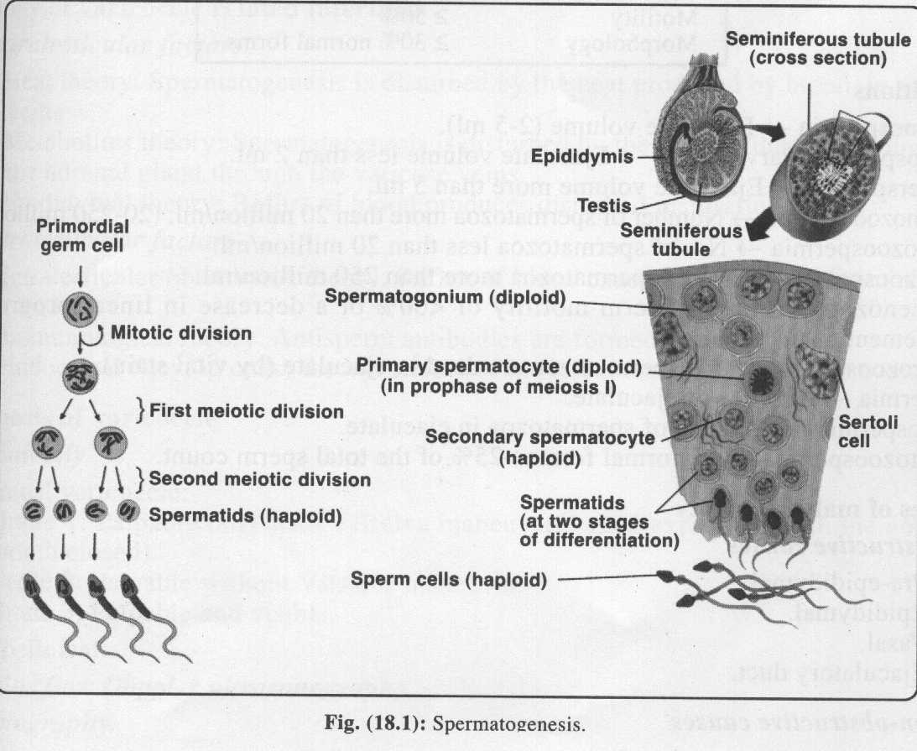

• Spermatogenesis begins at puberty after a long preparatory period of "prespermatogenesis" in the fetus and the infant.

**Causes of male infertility**

***A) Obstructive causes*** • Pre-epididymal.• Epididymal.• Vasal.

• Ejaculatory duct.

***B) Non-obstructive causes***

**I) Pretesticular (endocrinal) causes*.***

**II) Testicular causes:**

1. Primary testicular and sperm disorders.

2. Testicular arteries (torsion).

3. Testicular veins (varicocele).

**Ill) Post testicular:**

1. Coital (mechanical) infertility. 2. Immunological infertility.

**IV) Multifactorial causes:**

1. Varicocele 2. Infectious causes.

3. Neoplastic causes. 4. Medical causes.

∙ Investigations

• Normal semen analysis (at least 2 specimens)

* + - Volume: 2-5 mL
    - Count: > 20 million sperm/mL
    - Morphology: > 4% normal forms
    - Motility: > 50%
    - liquefaction: complete in 20 minutes
    - PH: 7.2-7.8 • WBC: < 10 per high power field
  + Hormonal evaluation
  + Chromosomal studies
  + Immunologic studies (sperm antibodies in ejaculate and blood)
  + Testicular biopsy
  + Scrotal U/S (varicocele, testicular size)
  + Vasography (assess patency of vas deferens)

**Definitions** • Normospermia *—>* Ejaculate volume (2-5 ml). • Hypospermia (Parvesemia) —> Ejaculate volume less than 2 ml. • Hyperspermia —> Ejaculate volume more than 5 ml. • Normozoospermia *—>* Number of spermatozoa more than 20 million/ml. (20-250 million/ml). • Oligozoospermia *—>* No. of spermatozoa less than 20 million/ml. • Polyzoospermia —> No. of spermatozoa more than 250 million/ml. • Asthenozoospermia *—>* Sperm motility of <60%. • Necrozoospermia —> All spermatozoa are dead in ejaculate (by vital stain). • Aspermia *—>* Absence of ejaculate. • Azoospermia —> Absence of spermatozoa in ejaculate. • Teratozoospermia —> Abnormal forms >25% of the total sperm count.

Treatment

• Medical

1-Endocrine therapy (Hyperprolactinemia, Hypothyroidism, Testosterone excess/deficiency)

2-Therapy for retrograde ejaculation: discontinue anti-sympathomimetic agents, may start

alpha-adrenergic stimulation (phenylpropanolamine, pseudoephedrine, or ephedrine)

3- treat underlying infections,

4- Antioxidant Therapy

• Surgical

• varicocelectomy

• vasovasostomy, epididymovasostomy, transurethral resection of ejaculatory duct

* Testicular Biopsy, Sperm Retrieval,

• Microsurgical epididymal sperm aspiration (MESA)

* ASSISTED REPRODUCTIVE TECHNOLOGIES (ART)

Intrauterine Insemination (IUI)

In Vitro Fertilization (IVF)

Intra-cytoplasmic sperm injection (ICSI).