***student guide***

**M3 2024-2025**

**Second term**

**Contents:**

* 1. 1- Characters of O.6.U. graduates**:**
  2. Teaching strategy in O.6.U.
  3. -Guide lines (why P.B.L. “Problem Based Learning”) (what the student & tutor will do this term) , (modules in this term & their general objectives)
  4. Schedule for lectures , practicals , Early clinical exposure (ECE) , cases ( small group teaching) , (small group discussion ) , skill lab , & exams
  5. Rubrics for grading assignments and presentations
  6. Portfolio items
  7. Cases with objectives
  8. 8- Tutor guide for the cases
  9. 9- N.A.R.S.
  10. Blue prints

**Characters of O.6.U. graduates:**

* 1. Work to maintain normal health, provide primary health care and deal with common health problems in the society
  2. Be aware of the importance of a good doctor patient relationship and work to establish and maintain it.
  3. Follow rules of medical ethics.
  4. Show appropriate attitudes and professionalism.
  5. Demonstrate appropriate communication, clinical and practical skills.
  6. Be prepared for lifelong learning.
  7. Be able to engage in post- graduate and research studies.
  8. Acquire basic administrative capabilities

**ملخص إستارتيجية التعليم والتعلم بالكلية\*\***

1.استراتيجية التعلم الذاتي:

أسلوب من أساليب التعلم المتطورة التى تمكن الطالب من تحصيل المعارف والمها ارت معتمداً على

قدارته الذاتية من مصادر التعلم المختلفة ، فيعلم نفسه بنفسه وفقاً لقدارته ولسرعته فى التعلم.

2ـ استراتيجيه التعلم التفاعلي:

تعتمد استراتيجية التعليم التفاعلي على إسلوب التفاعل بين الطالب والمحاضر والمادة العلمية ويمكن تطبيق هذا المفهوم من خلال عدة وسائل منها التعليم التعاوني والتعليم الإلكتروني.

أ- التعلم التعاوني:

من خلال عمل الطلاب معا فى مجموعات صغيرة العدد للعمل على حل المشكلات أو د ارسة حالة والمشاركة فى حملات التوعية في تفاعل إيجابي متبادل يشعر فيه كل فرد أنه مسئول عن تعلمه وتعلم الاخر .

ب-التعليم الالكتروني:

وسيمة تدعم العملية التعليمية وتحولها من طور التلقين إلى طور الإبداع والتفاعل وتنمية المها ارت، حيث تعتمد عمى تطبيقات الحاسبات الإلكترونية وشبكات الإتصال والوسائط المتعددة في نقل

المهاارت والمعارف وتضم تطبيقات عبر الموقع الالكترونى وغرف التدريس الإفتراضية.

3ـ التدريب

* التدريب الإكلينيكى
* التدريب الميدانى
* القوافل الطبية
* التدريب الصيفى بالمستشفى
* التدريب بمركز التدريب الطبى المستمر ووحدة الابحاث الطبية المتقدمة
* التدريب بالمستشفيات بالخارج

**\*\*اساليب وطرق التعليم والتعلم**

|  |  |  |
| --- | --- | --- |
| **أساليب أخرى لمتدريس التفاعمى** | **لاساليب الغير تقميدية** | **الاساليب التقميدية** |
| البحوث وتقديم العروض العملية  ) انشطة اخرى: المشاركة فى القوافل الطبية وحملات التوعية( | حل المشكلات | المحاضرات باستخدام الداتا شو |
| & Tutorial السيمينا ارت |
| الرسومات التوضيحية وعمل بوسترات للابحاث | نماذج ومحاكاة | الدروس المعملية والإكمينيكية  ) مستشفى الكلية ـ مستشفى طب القصر العينى  الكس  ترابيزة سكترا  التعليم باستخدام الحالات  التعليم التكاملي التفاعلي |
| Skill lab مشاهدة |
| التعلم الالكتروني | لعب الادوار |
| الزيا ارت الميدانية )الوحدات الصحية – المصل واللقاح – المحرقة بالمستشفى – وحدة التعقيم( | د راسة الحالة |
| التدريب الصيفى بمستشفى الجامعة وبالخارج | المناقشة فى مجموعات صغيرة |

**وللتأكد من تحقيق مخرجات التعلم المستهدفة:ـ**

يتم تقييم مستوى الطلاب بطرق متعددة تشمل:

* الامتحانات الدورية
* الامتحانات التحريرية
* حل المشكلات ودراسة الحالة
* الامتحانات العممية والاكلينيكية وتطبيق نظام) OSPE - OSCE

# عميد الكلية أ.د/عمرو نديم

* **PBL Philosophy:**

In a world where available information is growing exponentially, we believe that the most important thing a student needs to know is how to learn. So the main learning goals of the PBL are a framework for looking at concepts, skills, and abilities and help guide the creation of personalized student curriculum. PBL offers unique environments where students can flourish as individuals within a community of learners.

* **PBL Process:**

The core of the PBL process is the tutorials that will be held once weekly beside the practical sessions and the interactive lectures. In each tutorial there will be a case scenario that is delivered to the students, where they collaborate together through the seven jumps process to point out the possible problems present in the case and to find out the intended learning objectives need to be known through this case. In the second tutorial, they will discuss the objectives of the case after self study, and a new case will be delivered. In PBL process the role for lectures aim at clarification of complicated areas of information or to integrate different areas of information. Practical sessions and clinical skill lab are included as educational activities in BPL. They act as tools for the students to gain the needed psychomotor skills and to attain the professional attitude and behavior.

* **Student role:**

-The student is the center of the learning process in PBL. Students will depend on themselves in finding out the learning objectives by brain storming in the case study session. Then they will go home and study and search in the **texts or hand outs** for the information of the objectives they got. Then the following session they should try to present the information they gazered and summarized to their students in an easy palatable way. In BPL the students have to work hard, prepare themselves well for every tutorial group meeting, collaborate with their colleagues and practice team work. They also will have their reflection about the process, their colleagues and the tutor.

* **Tutors role:**
* The tutor will work as a facilitator more than traditional teacher who delivers all the information to the students. Tutors role is to stimulate and motivate the students to learn and to search for the information and knowledge. During the case they will guide the students and redirect them towards the intended learning objectives. The tutors share in the assessment process. Moreover, he share with the students the responsibility of setting the roles of the tutorial session.
* Tutor will divide the students into groups to work with each other.
* The tutor will receive guide information for the objectives in each case from the departments at least one week before the case is to be discussed, he should read them and then in the discussion of the case he should see if the students had fulfilled all the needed items so as to approve their work or they need to search more for certain items and get them so as to complete their work completely or they got more or un needed items they should discard them. By the end of the cases of the module students will have their hand out covering all items needed in the objectives they searched for
* All staff members should have their official mails done by the beginning of the academic year so as good communication may be applicable and to facilitate uploading of their lectures every Wednesday of each week
* In each session one of the students will be the reader (the one who reads the case) and another one will be the writer (the one who writes the objectives on the board after brain storming of the students with the tutor and collect them after that)
* In session ( 1 )
* One case will be red by the students
* They make brain storming with each other and with the tutor to reach the objectives the case is talking about. They will go home to search for them and make presentation about them the coming session according to rubrics given in this guide.
* Weeks for reading of the cases and discussion of the objectives are written above each case.
* The presentation have certain rubrics the tutor try that the students should stick more and more to them each time they make the presentation
* **STUDENTS SHOULD ATTEND THE CLINICAL DISCUSSION OF THE CASE**
* At the end of each module portfolio marks will be given according to :
* The attendance in the case sessions and the clinical case discussion
* **The presentation they showed along the module and their share in the discussions and preparation of the work needed (see professional behavior sheet included)**
* **The assignment they will be given which includes presentation and they should comply completely to the presentation and assignment rubrics (included in the guide)**
* **(the mark is given by the tutor and program heads after revising the assignments and discussing the students in them in the date of one of the case sessions scheduled with the students. This is to complete the mark of the portfolio for this module as shown in the assesment schedule included)**
* After the students finish the presentation in each session they will read the following case and brain storm to get the objectives that they will go home to prepare them as presentation in the coming case session and so on all the sessions
* If the case is long its presentation by the students may take two weeks not one week to ensure that the students presented the objectives in the case in a good way
* All students are to make their Emails in the first week and try to enter the learning management system on the moodle ([https://med@o6u.edu.eg/moodle)](https://med@o6u.edu.eg/moodle) so as to be able to have the on line information uploaded weekly and lectures , videos and on line formative exams as well as the grades

* **Scoring Rubric for Presentations:**

|  |  |  |  |
| --- | --- | --- | --- |
| **Category** | **Scoring Criteria** | **Total Points** | **Score** |
| **Organization (15 %)** | Were the main ideas presented in a clear manner? | 5 |  |
| Information is presented in a logical sequence. | 5 |  |
| Presentation appropriately cites requisite number of references. | 5 |  |
| **Content (45 %)** | * The Introduction is attention-getting, * It lays out the problem well, * It establishes a framework for the rest of the presentation. | 5 |  |
| Technical terms are well-defined in language that is appropriate for the target audience. | 5 |  |
| The Presentation contains accurate information. | 10 |  |
| The material included is relevant to the overall message/purpose. | 10 |  |
| Appropriate amount of material is prepared, and the points made reflect well their relative importance. | 10 |  |
| There is an obvious conclusion summarizing the presentation. | 5 |  |
| **Presentation (40 %)** | Speaker maintains good eye contact with the audience and is appropriately animated (e.g., gestures, moving around, etc.). | 5 |  |
| Speaker uses a clear, audible voice. | 5 |  |
| Delivery is poised, controlled, and smooth. | 5 |  |
| Good language skills and pronunciation are used. | 5 |  |
| Visual aids are well prepared, informative, effective, and not distracting. | 5 |  |
| Length of presentation is within the assigned time limits. | 5 |  |
| Information was well communicated. | 10 |  |
| **Score %** | **Total Points** | **100%** |  |

# **Professional Behavior of student in the case checklist**

**Students Name: ....................................**

**Date: ...................................................... End of module (Summative): ........................... Module title: .....................................................................** **Student’s Signature :............................ Tutor’s Name:.....................................................**

|  |  |  |  |  |  |  |  |
| --- | --- | --- | --- | --- | --- | --- | --- |
| **Criteria** | | |  | **Scale:** | |  | **Comments** |
| 1 and 2 is unsatisfactory,  3, 4 and 5 is satisfactory performance | |  |
| **Preparation:**  Is well prepared with relevant information, uses a variety of references and summarizes key points | | | | **1 2 3 4 5** | |  |  |
| **Critical thinking:** | | Identifies problem, analyzes problem, |  |  | |  |  |
| suggests possible reasons for the problem, helps group to formulate  learning objectives | |
| **1 2 3 4 5** | |  |
| **Participation:** | Participates actively, talks on turn and | |  |  | |  |  |
| listens attentively to others | **1 2 3 4 5** | |  |
| **Communication Skill & Group Skills:** | | |  |  | |  |  |
| Respects tutor and colleagues, communicates well uses appropriate language, accepts feedback and responds appropriately.    Contributes to group learning, shares information with others, demonstrates sensitivity to views and feeling of others, takes on assigned tasks willingly | | |
| **1 2 3 4 5** | |  |
| **Presentation skills:**  Presents the information relevant to the learning objectivse of the case, explains clearly the reasoning process with regard to solving the problem | | | |  | |  |  |
| **1 2 3 4 5** | |  |
|  | | |  |  | **SATISFACTORY** |  | **UNSATISFACTORY** |

**-****The students portfolio (October 6 university - faculty of medicine - 2024 - 2025):**

* Portfolio will be formed and submitted electronically
* **The student binder for the portfolio should contain the followings:**
* **Binder should contain the names of the group of the students, and contact information ( telephone , - emails ) , their leader and names and emails of their tutor (s),**
* Students should form the tasks needed and collect the presentations the group will do along the sessions of the cases and put them in the binder of the portfolio, with the cases , CV and the needed assignments , prochures , or links for the channels as will be announced

-Students should attend the clinical discussion case that will be held with the members of the departments sharing in the module

* Any community medical work the student completed under supervision of a staff presenting the followings:
* Name of staff & position
* Date
* Site
* Results
* ObstacleS
* Conferences attended by him if present
* Visits done to clinical departments to see relevant experiments if present.
* **PORTFOLIO SHOULD BE SUBMITTED IN FULL BY FIRST WEEK OF MAY.**
* **Portfolio scoring (Rubrics for evaluating portfolios):**
* **Each student should be rated as one of the followings :**
* Out standing & he will be given 95% to 100% of the portfolio mark
* Acceptable & he will be given 70% to 75% of the portfolio mark
* Marginal & he will be given 60% to 65% of the portfolio mark
* Unacceptable & he will be given less than 60% of the portfolio mark

**Schedule is available separately**

|  |  |  |  |  |
| --- | --- | --- | --- | --- |
| **OSPE** | **END MODULE** | **CONTNUOUS ASSESSMENT (portfolio )** | **MID MODULE** | **Third YEAR** |
| **30 marks total**  **-slides electronic and practical** | **40 marks total**  **30 MCQ**  **10 SAQs electronic** | **10 marks total** | **20 marks electronic** | **NHC 100** |
| **38 marks total**  **-slides electronic and practical** | **50 marks total**  **40 MCQ**  **10 SAQs electronic** | **12 marks total** | **25 marks electronic** | **ENT 125** |
| **45 marks total**  **-slides electronic and practical** | **60 marks total**  **50 MCQ**  **10 SAQs electronic** | **10 marks total** | **35 marks electronic** | **Surgery 150** |
|  |  |  |  | **EMD 50** |

**Portfolio tasks and blue prints:**

**ENT blue print**

**The blue print for the module ENT (Code 308)**

|  |  |  |  |  |  |  |
| --- | --- | --- | --- | --- | --- | --- |
| **Topics** | CH | Weight | Total Marks  Midterm MCQ, Final MCQ+ SAQ | **No of MCQs in mid term exam**  **(1 mark)** | **No of MCQs** in END of term exam | **No of SAQ** in END of term exam |
| Anatomy of external ,middle ,inner ear  Anatomy of nose and sinuses  Anatomy of pharynx and larynx | **3** | **6.6%** | 4 | 2 | 2 |  |
| Histology of external middle ,inner ear  Histology of Nose and paranasal sinus  Histology of pharynx and larynx | **3** | **6.6%** | 4 | 2 | 2 |  |
| Physiology of external and middle and inner ear  Physiology of nose and sinuses  Physiology of swallowing | **3** | **6.6%** | 4 | 2 | 2 |  |
| Pathology of external ,middle ,inner ear  Pathology of Nose and paranasal sinus  Pathology of pharynx and larynx | **4** | **8.8%** | 7 | 3 | 4 |  |
| Microbiology of external middle ,inner ear  Microbiology of nose and sinuses  Microbiology of pharynx and larynx | **3** | **6.6%** | 4 | **2** | 2 |  |
| Diseases of Ear external, middle, and inner ear | **6** | **13.3%** | 12 | **4** | 3 | 1 (5 marks) |
| Diseases of Nose and paranasal sinus | **6** | **13.3%** | 12 | 6 | 6 |  |
| Diseases of pharynx and larynx | 6 | 13.3% | 12 |  | 7 | 1 (5 marks) |
| Diseases of trachea | 3 | 6.6% | 4 |  | **4** |  |
| Diseases of oseophagus | 3 | 6.6% | 4 |  | 4 |  |
| History and investigations of ear, nose, and throat | 2 | 5.1% | 6 | 4 | 2 |  |
| Emergencies in ENT | 3 | 6.6% | 4 | 2 | 2 |  |
| Total | 45 | 100% | 67+2 SAQ | 27 | 40 | **2= 10 marks** |

**Task portfolio ENT**

**Attend 2 clinics for the ENT**

**EMD module**

**The blueprint for the module (sub block (code) EMD 310)**

|  |  |  |  |  |
| --- | --- | --- | --- | --- |
| **Topics** | **Teaching hours (lectures)** | **Weight** | **No of marks in End module exam** | |
| **MCQ** | **SAQ** |
| Fertilization, Morula, Implantation, Chorionic vesicle, and Decidua | 3 | 10 % | 5 |  |
| Changes of embryoblast & Folding | 3 | 10 % | 5 |  |
| Placenta & Fetal membranes | 3 | 10 % | 5 |  |
| Pharyngeal arches, pouches, clefts, face & palate | 3 | 10 % | 5 |  |
| Development of the nervous system | 3 | 10 % | 5 |  |
| Development of CVS | 5 | 17% | 4 | 5 |
| Development of respiratory & digestive system | 5 | 17% | 4 | 5 |
| Development of urogenital system | 5 | 16% | 7 |  |
| **Total** | **30** | **100%** | **40** | **10** |

## Cases

**Cases for the Third year students ( second term ) :**

**Hit by an axe: ( pathology , pharmacology , surgery , microbiology , pharmacology )**

Amgad is a 35 years old farmer whom his leg was hit by an axe. A relative of him cleaned the wound with clean water then badaged the whole limb. He went home and next morning he started irrigating his land. He felt pain in his leg which increased the following days and it became red , swollen around the wound region, and his walking using it became very difficult.

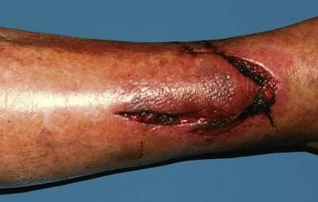

After few days Amgad temperature began to rise , and reached 38 degrees. His brother Akram took him to the hospital where the surgeon said that the wound was very deep , oozing and infected with spreading cellulitis and that he can not suture the skin immediately. The surgeon referred him to the wound dressing room, where his wound was irrigated with normal saline, and all foreign bodies were removed.

The surgeon ordered an X- ray to be done to Amgad and gave him antibiotic Amoxicillin to be taken daily every 8 hours for two weeks. The doctor excluded tetanus infection.

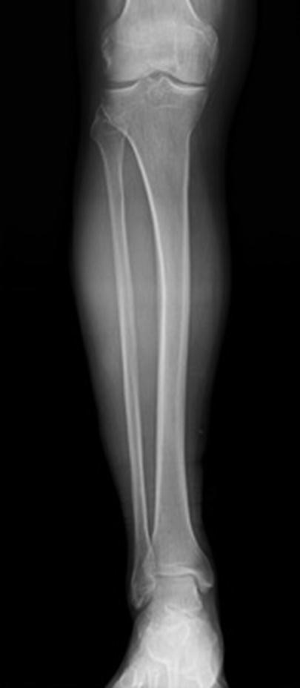

**Objective 1**

-Do you think the 1st aid management of the wound was right and efficient ? (surgerypathology )

-What is the standard management in these situations ? ( surgery – pathology )

-Why did the doctor ask for a plan X ray ? ( radiology – surgery )

-Should we consider Tetanus prophylaxis in this patient ? ( microbiology , surgery )

-Discuss the antibiotic amoxicillin and its major side effects ( pharmacology )

-Discuss types of wounds ( surgery)

After two weeks Unfortunately, Amgad was not doing well, he was still feverish, the wound was still oozing with erythema of the skin around and evident tenderness. He seemed not to be responding to the treatment. The doctor suspected bone infection.

**Objective 2:**

**-**what are the possible explanation for the wound not to be responding to the management given by the doctor ? (surgery - pathology )

**-**Why the doctor suspected bone infection? How you think infection reached the bone?

Could we confirm it by any investigation? ( pathology – surgery – radiology )

**-**Can plane X ray help in diagnosis? ( radiology – surgery )

**-**Mention the general principles for prescribing antibiotic in acute osteomyelitis ( pharmacology , pathology )

Along the following few weeks Amgad pain never disappeared , his limp became more evident. He began to use crutches , abnormal swelling appeared at the site of trauma , and skin overlying appeared unhealthy. He visited his surgeon who ordered another plane x- ray to him.

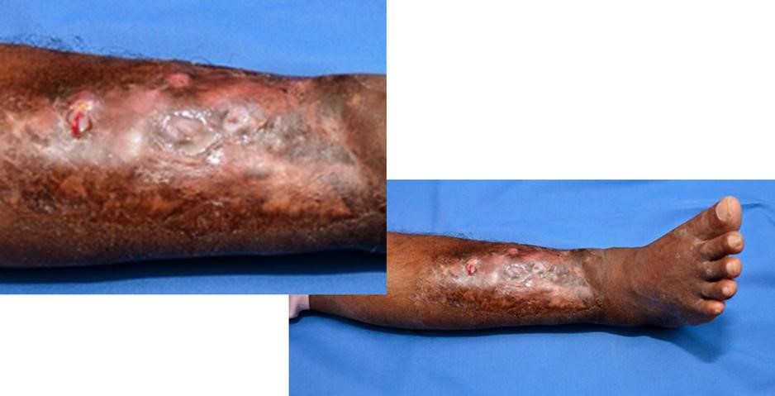

Skin appearence

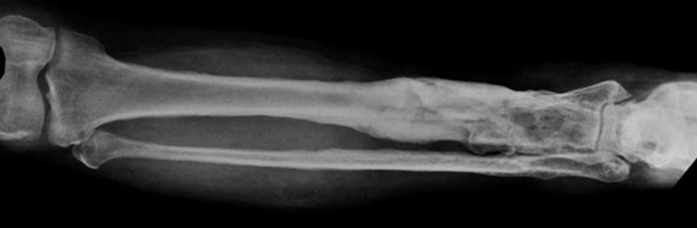

Plain x ray

**Objective 3:**

**-What are the clinical signs apparent on the skin ?** ( pathology )

**-What are the Radiological findings in the X ray?** ( radiology )

The surgeon said that Amgad developed chronic osteomyelitis.and ordered him culture and sestivity test to prescribe him the proper antibiotic.

**Objective 5 :**

**-What are the characteristic microbiology features of chronic osteomyelitis?** (microbiology )

-why di Amgad developed osteomyelitis ? ( pathology )

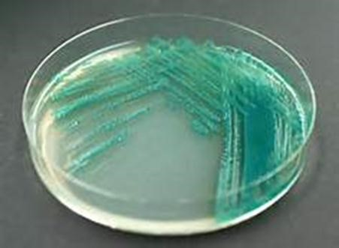

bacteriological tests revealed mixed growth of two organisms. The report described the first organism as “MERSA”. Subculture and the second organism was shown in the above picture.

**Objective 6 :**

-Considering the bacteriological growth, what are the antibiotics that should be included in the antibiotic sensitivity test? ( microbiology , pharmacology )

Few months later Amgad both feet and legs showed **soft pitting edema**. His serum **albumen was 1.6 gm/dl**.

**Objective 7 :**

-What is the new condition Amgad developed ? ( pathology )

**Case 2:**

Ahmed is a third year student in the O6U. he is in his case session and introducing the assignment made by his group about cleft lip and palate. They made the assignment according to the rubrics.

* Cleft lip and/or palate (CL/P) represents the most common of the congenital facial anomalies, making up approximately 65% of all craniofacial malformations.
* The incidence of CL/P is approximately 1 in every 500-2,000 live births, varying according to geographic location, and race.
* 70% of the affected individuals develop non-syndromic CL/P, in other words, without association with other malformations and without behavioral and/or cognitive changes.
* The remaining 30% are associated with Mendelian disorders (dominant autosomal, recessive autosomal or x-linked), chromosomal, teratogenic or sporadic conditions which include multiple congenital defects.
* Even being a common congenital defect, CL/P etiopathogeny is still uncertain. This is mostly a reflex of the complexity and diversity of the molecular mechanisms involved in embryogenesis, with the participation of multiple genes and the influence of environmental factors.
* It is widely accepted that CL/P has a multifactorial etiology, with genetic and environmental components. Among the environment risk factors for CL/P are:

1-maternal diet and vitamin supplements,

2-alcohol ingestion, smoking,

3-the use of anti-seizure medication in the first quarter of gestation 4- maternal age

* Clinically speaking, CL/P is classified in four groups based on its location in relation to the incisive foramen, as follows:

A-pre-foramen clefts, or simply: labial fissures (LF),

B-post-foramen fissures (PF),

C-trans-foramen fissures or lip-palate fissures (LPF), D-rarely facial fissures

* It is difficult to describe and to distinguish between the varied forms of presentation of these malformations.

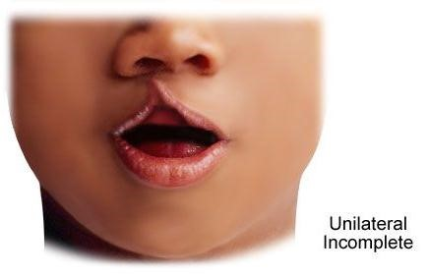

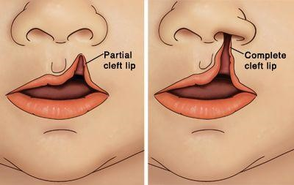

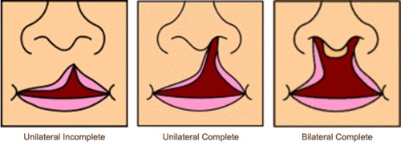

**Objective 1:**

-Discuss the embryologic development of the lip and palate ( embryology )

-Discuss the repaire of cleft lip and palate ( surgery )

**Tutor guide surgery :**

# Tutor guide

**-Comment on the 1st aid management of the wound done first. What is the standard management in a these situations ?**

* As the wound was deep. It should have been managed in the hospital at first place.
* For deep wounds contaminated with soil we should consider gram positive spores beside inoculation with staph organisms.
* Wounds should be thoroughly irrigated with sterile physiological solution (Normal saline) to insure removal of ALL foreign bodies.
* Any unhealthy tissue should be surgically removed.
* Proper surgical debridement and irrigation + antibiotics against gram +ve cocci and garm +ve rods are enough.
* NO NEED FOR ANTI GAS GANGREEN.
* ANTI TETANIC SERUM and Tetanus immunization are g*iven for Tetanus prone wounds}*

**-Why did the doctor ask for a plan X ray?**

* The wound is deep and is related to the underlying chin of tibia which is anatomically just beneath the skin & subcutaneous tissue. The X ray will identify any underlying bone fracture*.*
* *The wound was infected [possible bacterial inflammation] (red, swollen painful, and oozing). It is logic not to suture an apparently infected wound.*
* Infected wounds need frequent dressing and antibiotics. We should choose the antibiotic to cover the expected contaminant bacteria. These are predominantly “staph”. Amixacillin is not an ideal choice. A field wound contaminated with soil is potentially contaminated with spore forming gram +ve bacilli. Clostridia are sensitive to penicillin*.*

**-Should we consider Tetanus prophylaxis in this patient? WHO Protocol**: Management of tetanus-prone wounds

* 1. Wounds are considered to be tetanus-prone if they are sustained either more than 6 hours before surgical treatment of the wound or at any interval after injury and show one or more of the following: a puncture-type wound, a significant degree of devitalized tissue, clinical evidence of sepsis, contamination with soil/manure likely to contain tetanus organisms, burns, frostbite, and high velocity missile injuries.
  2. For patients with tetanus-prone injuries, WHO recommends TT or Td and TIG.
  3. When tetanus vaccine and tetanus immunoglobulin are administered at the same time, they should be administered using separate syringes and separates sites*.* **- What is the possible explanation for not responding to the treatment ?** - Antibiotic not covering the spectrum of the contaminating organisms
* The possible presence of a foreign body in the wound if wound irrigation & debridement was not enough
* If the underlying periosteum is injured and infection directly spread to the underlying bone (acute osteomyelitis) , the treatment duration should be for 6 weeks with a broad spectrum antibiotic.

* **Why the doctor suspected bone infection? How do you think infection reached the bone? Could we confirm it by any investigation?**

Clinical suspicion, deep wound with proximity to bone, x ray showing fractured bone with an opened wound (compound fracture). Yet even if the bone is not fractured, injury to the periosteum can invite infection into the bone. In this case, infection can reach the bone directly. Hematogenous spread is a rather remote possibilit*y* **-Would a plane X ray help in diagnosis?**

Acute osteomyelitis is suspected and managed on clinical criteria. X ray is usually normal at this stage

* **What are the general principles for prescribing antibiotic with acute osteomyelitis ?** 
  + The causative organism is usually Staphylococcus aureus, so the antibiotic spectrum should cover it
  + Bioavailability of the drug should be considered
  + The treatment duration should be for 6 weeks at least. It should start by an injectable antibiotic for the 1st two weeks follower by oral antibiotic for another 4 weeks
  + The long duration of treatment is related to the poor bone blood supply

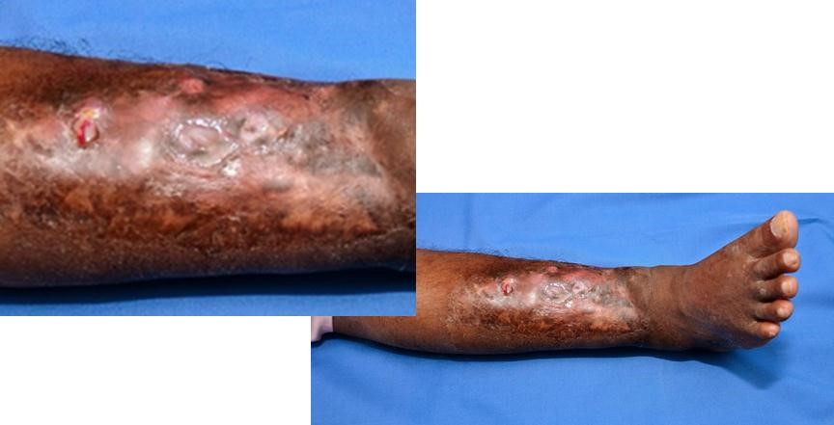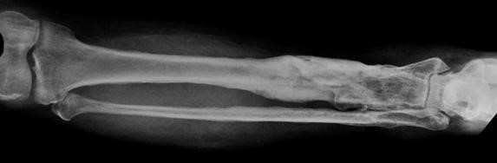

**-What are the clinical signs apparent in the picture of skin ?**

Thick pus discharging from skin openings (multiple sinuses) with limb swelling  **- What are the characteristic Radiological findings in the X ray?** Bone destruction with new bone formation. sequestrum **-Why did Amgad developed chronic osteomyelitis?**

*(Pathology of chronic osteomyelitis)*

* **Why is C&S essential? What are the characteristic microbiology features of chronic osteomyelitis?**

Chronic osteomyelitis is usually poly-microbial. Because of the infection chronicity and expected frequent use of antibiotics, infection with resistant strains is the usual

(MERSA, ESBL). Long term antibiotic therapy is the rule

Because of bone vascularity (particularly the sequestrum), excision of the chronically infected and destroyed bone is essential to eradicate infection

The bacteriological tests revealed mixed growth of two organisms, the report describes the 1st organism as “MERSA”. Subculture for the 2nd organism is shown in this picture

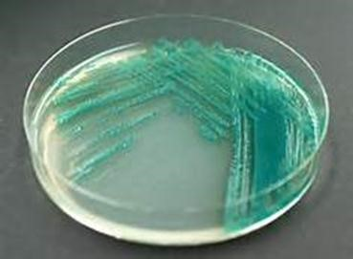

**-Considering the bacteriological growth, what are the antibiotics that should be included in the antibiotic sensitivity test?**

Anti MERSA & anti pseudomonas antibiotics **- What did Amgad developed at the end ?** *Amyloidosis of the kidneys*

## Cases for the module ENT

**Case 1**

Epistaxis (Bleeding per nose)

Objectives

* To take history
* To define causes
* To learn first aid
* To Describe management

**Case 2**

Deafness

Objectives

* To take history
* To define causes
* To explain causes
* To learn Tuning Fork tests
* To Describe management

**Case 3**

Stridor (difficult noisy breathing)

Objectives

* To take history
* To define causes
* To learn first aid
* To Describe management **Tutor guide of module ENT :**

**Case 1: Epistaxis (Bleeding per nose) Causes of epistaxis:**

***Local causes***

1. Idiopathic: 90% from Little's area.
2. Traumatic: FB, fractures nasal bones and skull base, after nose surgery.
3. Inflammatory: Acute and chronic rhinitis.
4. Neoplastic: Benign and malignant tumours of nose, sinuses and nasopharynx (nasopharyngeal fibroma and carcinoma).
5. Deviated nasal septum: congestion from angulations.

***General causes:***

1. Hypertension: commonest cause in elderly (anterior ethmoidal artery).
2. High venous pressure: cardiac and pulmonary diseases.
3. Blood diseases: Purpura, leukaemia, haemophilia.
4. Vitamin deficiency: vitamin C (scurvy) and vitamin K (liver diseases).
5. Drugs: Anticoagulants, salicylates.

**Site of bleeding:**

1. Little's area: The site of 90% of cases of epistaxis.
2. Above the middle turbinate in cases of hypertension.

**Management of epistaxis**:

1. ***First aid stop the bleeding:***

-Place the patient in the sitting position (decrease venous congestion).

-Put a piece of cotton soaked in adrenaline or nasal vasoconstrictive drops in the nose and compress the nose from outside.

-Cold compresses may be applied to cause reflex vasoconstriction.

1. ***Nasal packs:***

*-Anterior nasal pack*: A50 cm Vaseline gauze is packed into the nose in layers from below upwards and removed after 24-48 hours. Recently Merocel packs

are used because of its easy insertion in the nose.

*-Posterior nasal pack:* Indicated when, the anterior nasal pack fails or the bleeding is coming from a posteriorly placed lesion.  ***3. Cautery of the bleeding vessel: by***  - Electric cautery.

- Chemical cautary: 50% silver nitrate sticks or crystals of chromic acid.

***4. Surgical treatment****:* when cautery or packs fail or epistaxis is severe. a) Arterial ligation: of

-Endoscopic sphenopalatine artery ligation.

-Maxillary artery in pterygopalatine fossa through maxillary sinus.

-Ligation of the external carotid artery.

b) Submucous resection of severe deviated septum.  **General treatment:**

-Control hypertension, give coagulants drugs and vitamin K.

-Blood transfusion in severe cases.

-Treatment of the cause.

**Investigations of epistaxis:**

- Blood picture: for

1. Haemoglobin for anaemia.
2. White cell count for leukemias.
3. Platelets for purpura.
4. Bleeding coagulation and prothrombin times.  **Case 2: Deafness**

**Types:**

-Conductive deafness. (CHL)

-Perceptive deafness (Sensorineural Hearing Loss) (SNHL).

-Mixed (conductive and perceptive deafness).

-Functional (psychogenic and malingering) deafness.

**CONDUCTIVE DEAFNESS**

Conductive deafness is caused by diseases of the external or middle ear.  **A) External ear:**

1. Congenital: Atresia.
2. Wax: Accumulation (commonest cause)
3. Foreign body: Impaction.
4. Inflammatory: Otitis externa, big furuncle and fungal mass.
5. Neoplastic: Exostosis and carcinoma.  **B) Middle ear:**

A) Drum: Perforation and adhesions.

1. Trauma: - Haemotympanum (fracture base), Otitic barotraumas
2. Inflammatory: acute and chronic suppurative otitis media

- Non-suppurative otitis media (secretory and adhesive otitis media). d) Neoplastic: Glomus jugulare and carcinoma.  **-Ossicles:**

1. Congenital: Absence or fixation.
2. Trauma: Dislocation.
3. Inflammation: Necrosis or adhesions.
4. Otosclerosis.  **-Eustachian tube:**
5. Inflammation: salpingitis.
6. Allergy: Causing edema.
7. Mechanical obstruction: by adenoids or nasopharyngeal tumours.

**Management of frequent causes of conductive deafness:**

-Ear wax: Ear wash.

-Secretory otitis media: Myringotomy and insertion of Grommet tubes.

-Chronic otitis media: Tympanoplasty.

-Otosclerosis: Stapedectomy.

**PERCEPTIVE (SENSORINEURAL) DEAFNESS**

Sensorineural hearing loss is caused by diseases of the inner ear, cochlear nerve or brain.

**A. Cochlear lesions:**

**1- Congenital:**

1. Genetic: Consanguinity (marriage of relatives).
2. Prenatal: German measles affecting the mother during the first trimester of

pregnancy and intake of ototoxic drugs. c) Natal: Birth injury or anoxia.

d) Post-natal: Kernicterus (Rh incompatibility).  **2- Trauma:**

1. Head injuries: Fracture skull base.
2. Acoustic trauma: acute as blasts or chronic as in factories due to long

exposure to loud noise.  **3- Inflammatory: (labyrinthitis)**

1. Viral: Measles, mumps and influenza.
2. Bacterial: Meningitis, typhoid, tuberculosis, syphilis and complications of

chronic suppurative otitis media.

**4- Toxic: (ototoxicity)**

1. Endogenous: Diabetes mellitus, uraemia and hypothyroidism.
2. Exogenous: Streptomycin, neomycin, kanamycin and quinine. **5- Vascular:**

Spasm, hemorrhage or thrombosis of the internal auditory artery. **6- Miscellaneous:**

1. Senile deafness (Presbycusis) is the most common cause of SNHL in adults.
2. Menière’s disease and cochlear otosclerosis **B. Cochlear nerve lesions:**

Tumours: acoustic neuroma. **C. Brain lesions:**

1. Vascular: vertebrobasilar insufficiency.
2. Tumours.
3. Multiple sclerosis.
4. Epilepsy.

**Auditory rehabilitation Hearing aids**

It is indicated when medical or surgical treatment fails to regain hearing.

**Principle:**

-A microphone: collects sounds and transfers it to electric signals.

-Amplifier: amplify electric signals.

-Receiver: transfers the amplified signals to acoustic signals.

-Styles: behind the ear, all in ear canal, pocket and eye glass hearing aid.

**Cochlear implant**

It is a surgically implanted electronic device coupled to external component to stimulate the auditory nerve.

It is indicated in cases of bilateral total sensory loss (cochlear) and the auditory nerve should be intact.

**The device is composed of:**

-External part: outside the skull (microphone, speech processor and transmitting coil).

-Internal part: the receiver is placed surgically beneath the scalp in the postauricular area over the mastoid and the electrode is internally implanted in the

scala tympani through the round window to directly stimulate neural fibres.

**Selection of patients:**

-Post-lingual deafness: deafness occurred after completion of speech development. These patients can return to hearing world after cochlear

implantation.

-Pre-lingual deafness: deafness occurred prior to speech development. These patients will not get the same benefit as post-lingual ones.

**Case 3: Stridor (difficult noisy breathing)**

It is difficult noisy breathing due to partial obstruction of the airway (larynx, trachea or bronchi).

**Dyspnea:** Difficulty in breathing, often associated with lung or heart disease and resulting in shortness of breath.

**Types of stridor:**

-Inspiratory stridor: indicates obstruction at the level of the larynx (glottic and supraglottic area), it is high pitched.

-Expiratory stridor: indicates bronchial obstruction as in bronchial asthma or foreign body in a bronchus.

-Biphasic stridor (inspiratory and expiratory): indicates subglottic or tracheal obstruction: malignant thyroid, lymphadenopathy, mediastinal tumours.

**Causes of laryngeal obstruction (Stridor):**

1. Congenital: Laryngomalacia, glottic web.
2. Traumatic: Foreign body, chemical, operative.
3. Inflammatory:
   1. Acute laryngitis in children, acute epiglottis and diphtheria.
   2. Chronic specific laryngitis: scleroma, syphilis and T.B.
4. Neoplastic: Multiple papilloma in children, Malignancy in adults.
5. Allergic: Laryngeal edema.

6 - Neuromuscular: Bilateral abductor paralysis.

**Causes of stridor in infancy and childhood:**

1. Congenital: Laryngomalacia,, glottic web and vocal folds paralysis.

1. Inflammatory: Acute non specific laryngitis in children.

Acute epiglottitis and diphtheria.

1. Traumatic : F.B. inhalation 4- Neoplastic : Multiple papilloma.

5-Laryngismus stridulus : It is apyrexial laryngeal spasm causing stridor in children at night. The child is free by the day. It is common in ill health and malnourished children. Treatment: good diet, vitamins and minerals (vitamin D

and calcium).

**Symptoms of laryngeal obstruction:**

1. Dyspnea is at first present on exertion then at rest.
2. Stridor is at first inspiratory and on exertion. Later it becomes inspiratory and expiratory.
3. Tachypnea (rapid breathing).
4. Nervousness and irritability.

**Signs of laryngeal obstruction:**

1. Cyanosis and congestion of the neck veins.
2. Recession of the suprasternal, supraclavicular and intercostal spaces.
3. Tachycardia (rapid pulse).
4. Contraction of the accessory muscles of respiration.

**TRACHEOSTOMY**

It is a surgical opening in the anterior wall of the cervical trachea.

**Indications of tracheostomy:**

1. **Upper respiratory tract obstruction:**

All causes of stridor (see before).

1. **Lower respiratory tract obstruction (lower trachea, lungs and bronchi):** Wet lung syndrome: This occurs in conditions inhibiting the cough reflex, causing retained secretions inside the alveoli and impairment of the exchange of gases leading to hypoxia and hypercapnea. The patient will be drowned in his

own secretions. **Causes of wet lung syndrome:** Prolonged coma  **3. Pre-operative:**

-Before major head and neck surgeries to prevent blood inhalation.

**Value of tracheostomy:**

1. To bypass obstruction of the upper airway.
2. To aspirate the accumulated secretions as in wet lung syndrome.

**Time of tracheostomy:**

-Urgent: if there is respiratory obstruction.

-Elective: if respiratory obstruction is anticipated e.g. preoperative.

**Post-operative care:**

1. The patient should be semi-sitting to allow for cough.
2. Ensure patency of the tube.
3. Frequent suction of secretions to prevent blocking of the tube.
4. Decannulation after the indication for tracheostomy is treated.

5-The tracheostomy is permanent in case of total laryngectomy or inoperable cancer larynx

**Complications of tracheostomy:**

**1- Shock:**

Anaphylactic shock from local anaesthesia.

**2. Haemorrhage:**

1. Primary: anterior jugular vein, thyroid isthmus or innominate vein in

children.

1. Reactionary (during the first 24 hours): The wound should be reopened and

the bleeding vessels are ligated.

1. Secondary haemorrhage. After one week due to infection.

**3. Injury of:**

1. Blood vessels e.g innomonate vein.
2. Pleura, especially in low tracheostomy leading to pneumothorax.
3. Oesophagus: Causing tracheo-oesophageal fistula.
4. Cricoid cartilage: high tracheostomy causes perichondritis of the cricoid

cartilage and later subglottic stenosis.

**4. Pulmonary complications:**

1. **Apnea**: Arrest of respiration due to sudden wash of CO2 which was acting as

stimulus for the respiration due to long standing obstruction.

*Treatment:* Close the opening for a short time to allow accumulation of CO2.

1. **Pulmonary edema**: Due to sudden release of pressure inside the lungs and

exudation from the capillaries. It causes noisy respiration, and cyanosis.

*Treatment*:Respiratory and cardiac stimulants.

1. **Pneumothorax**: Due to injury of the apex of the pleura especially in children

and low tracheostomy..

*Treatment*: Chest tube attached to an underwater seal.

1. **Surgical emphysema**: Of the neck due to air leakage around a small tube, wide tracheal opening or tight skin sutures during inspiration. It may extend to

the mediastinum.

*Treatment:* Re-open the wound to allow air out and change tube with a larger one.

**5. Infection:**

1. Wound infection.
2. Chest infection.  **6. Tube problems:**
3. Slipped, blocked tube may cause respiratory obstruction.
4. Long curved tube causes injury of the oesophagus (fistula).
5. Subglottic stenosis after high tracheostomy.

## Cases for the module NHC

**New Universal Health Insurance law Objectives :**

**-Mention the primary aim of it**

**-Mention how it is implemented**

**-Mention how it is funded**

**- Mention the TIMELINE FOR THE IMPLEMENTATION OF THE LAW**

**Tutor guide for the module NHC :**

**New Universal Health Insurance law :**

Universal Health Insurance Law No. 2 of the year 2018 (the „Universal Health Insurance

Law‟) was promulgated. The promulgation of the Universal Health Insurance Law comes as part of the Egyptian government‟s recent attempts to restructure and reform the healthcare sector by introducing improved and effective policies, refining subsidy reallocation, and launching various healthcare initiatives, such as the nationwide screening. It is expected that the universal insurance programme brought forth by the Universal Health Insurance Law will revamp the ineffective and out-dated health insurance system currently in place, by way of generating and properly injecting and allocating public funds in the healthcare sector. The most prominent changes to expect from the new health insurance programme are universal

inclusion and access to affordable health care services.

**The primary aim of the Universal Health Insurance Law** is to provide universal coverage and to grant access to Egyptians who had limited access to healthcare or none at all, under the previous health insurance scheme. Accordingly, the Universal Health Insurance Law provides for the compulsory enrolment of all Egyptian citizens residing in Egypt in the universal health

insurance programme.

**1. Implementation**

The Universal Health Insurance Law will be progressively implemented across Egypt, with the aim of covering all Egyptian governorates by 2032.

The implementation process will take place over six phases, each phase focusing on a different geographic area (i.e. a cluster of governorates). The first phase includes Port Said, and the last phase of the implementation process will cover Cairo, Giza, and Qalyoubeya.

The first phase has already been launched in Port Said, where the trial programme started on 1 July 2020. **The purpose of implementing the programme** gradually is to allow ample time for each governorate to prepare and improve the quality of healthcare services provided to Egyptian citizens, and in order to allow the regulatory authorities overseeing the implementation of the programme time to assess and rectify the shortcomings of such implementation, so as to enhance such implementation during the subsequent phases. The implementation of the programme will be funded from various sources by way of imposing

taxes and fees on different industries and sectors

1. **Regulatory Authorities**

The Universal Health Insurance Law introduced ***three new independent regulatory*** authorities, which will oversee the effective implementation of the universal health insurance

programme. Those regulatory authorities are as follows:

* 1. The General Authority for Accreditation and Health Control (the „GAAHC‟)
  2. The General Authority for Healthcare (the „GAHC‟)

(iii)The General Authority for Universal Health Insurance (the „GAUHI‟).

Those regulatory entities are subject to the supervision of the Ministry of Finance and the Central Auditing Organization.

* 1. ***The GAAHC is a public services authority***, which is subject to the supervision of the President. The primary role of GAAHC is to monitor transparency, set healthcare quality standards, and to supervise the compliance of healthcare service providers with national and international standards. Additionally, the GAAHC will also select the service providers to include within the program‟s network. Private and public healthcare providers are under an obligation to obtain an accreditation certificate from GAAHC within three years from the effective implementation of the universal healthcare program in their respective governorate.
  2. ***The GAHC is a public services authority*** *w*ith an independent budget, which is subject to the supervision of the Ministry of Health and Population (the „MOHP‟). The main role of the GAHC is to regulate the healthcare service providers and supervise the provision of healthcare services
  3. ***The GAUHI is an economic authority*** with an independent budget, which is subject to the supervision of the Prime Minister. The main role of the GAUHI is to finance the universal health insurance scheme through the collected funds and to manage such funds. The GAUHI will invest such funds based on a pre-determined investment strategy. The GAUHI will also be involved in financing medical services and pricing medical services.

1. **Funding**

The Universal Health Insurance Law imposes fees and contributions on various sectors and industries, as well as on natural persons and corporate entities, in order to finance the universal health insurance program. The GAUHI will co-ordinate with and solicit the assistance of different authorities, including the MOHP, the tax authorities, the Ministry of Transport, and the Ministry of Interior to collect such taxes and fees on its behalf.

The Universal Health Insurance Law determined nine sources of funding, and the most significant sources are the following:  **a. Corporate Social Contribution**

The most prominent change brought about by the Universal Health Insurance Law is the introduction of a new corporate tax imposed on all Egyptian corporate entities. Such corporate tax amounts to 0.25 percent of revenues, payable by all Egyptian companies, calculated based on the tax returns presented to the competent tax authority. It is worth noting that such corporate social contribution is not deductible from a corporate entity‟s income tax. Unlike other taxes and fees, companies in all governorates (irrespective of the Universal Health Insurance Law implementation phase under which the company‟s location falls) start paying such corporate tax based on the tax returns submitted as of April 2019.  **b. Individuals**

Under the Universal Health Insurance Law, individuals subject to the provisions of the legislation will pay their contribution in accordance with brackets determined by the law, irrespective of whether such individuals are subject to the provisions of any other applicable social insurance laws. Such contribution applies to, amongst others, all employees, members of the liberal professions (i.e. independent professionals such as physicians and lawyers), and their family members (i.e. spouses, children, dependents). As *for unemployed individuals* or those deemed unable to afford payment of such contribution, the *government will cover their*

*contribution by paying five percent of the minimum monthly wage on their behalf*.

*Employers*, on the other hand, w*ill pay a monthly contribution amounting to four percent of*  *the employee’s insured salar*y.

**c. Additional Sources of Funding**

The Universal Health Insurance Law will also derive funding by imposing:

1. AN EGP 0.75 (approximately US$0.043) fee on each cigarette packet, subject to an EGP

0.25 (approximately US$0.015) increase every three years;

1. A 10 percent tax on tobacco products (save for cigarettes);
2. A fee amounting to EGP 1 (approximately US$0.058) on each vehicle passing through a highway toll station;
3. An annual fee amounting to EGP 20 (approximately US$1.16) from individuals extracting or renewing their driver‟s licence;
4. An annual fee ranging between EGP 50 (approximately US$2.9) and EGP 300

(approximately US$17.4) on individuals/entities extracting or renewing vehicle licences, depending on the vehicle‟s engine capacity;

1. A fee varying between EGP 1,000 (approximately US$58) and EGP 15,000

(approximately US$87) from clinics, healthcare centres, pharmacies and pharmaceutical companies subscribing to the universal healthcare scheme; and

1. A fee amounting to EGP 1,000 (approximately US$58) on each bed upon issuance of a licence to open a hospital or a medical centre.

1. **Beneficiaries**

With respect to beneficiaries, the Universal Health Insurance Law seeks an all-encompassing reach and implementation, making enrolment mandatory for all Egyptian nationals residing in

Egypt (excluding military personnel); while enrolment remains optional for Egyptians nationals residing abroad.

1. **Implications of the Universal Health Insurance Law**

The Egyptian healthcare sector is characterised by an ever-growing gap between public and private funding; such a gap also highlights the discrepancy between the quality of healthcare services and healthcare providers in both sectors. It is expected that the inclusive nature of the Universal Health Insurance Law will grant access to better healthcare services to the wider population when compared to the previous ineffective regime. However, the implementation of such an ambitious programme will not be ***without its challenges***, which will hopefully be overcome during the prolonged implementation process. Moreover, although the implementation of the programme is still in its early stages, it is undeniable that the new universal health insurance scheme will have a significant impact on the private healthcare sector, given the involvement of the new regulatory authorities in pricing and regulating healthcare services. Such involvement by the regulatory authorities may decrease the

profitability of the healthcare services provided by the private sector.

On the other hand, well-prepared *private service providers may benefit from more stable contracts and an increase in the volume of patient*s. Investors will be closely monitoring the implementation of the universal health insurance regime and assessing its implications on the

private sector.

|  |  |  |  |  |  |  |  |  |
| --- | --- | --- | --- | --- | --- | --- | --- | --- |
| **Population data in thousands3** | | |  |  |  |  |  |  |
|  | **2019** | **2018** | **2017** | **2016** | **2015** | **2000** | **1990** | **1980** |
| Total population | 100'388 | 98'424 | 96'443 | 94'447 | 92'443 | 68'832 | 56'134 | 43'309 |
| Births | 2'577 | 2'591 | 2'602 | 2'607 | 2'600 | 1'787 | 1'859 | 1'698 |
| Surviving infants | 2'539 | 2'551 | 2'560 | 2'564 | 2'555 | 1'730 | 1'735 | 1'494 |
| Pop. less than 5 years | 12'804 | 12'972 | 13'070 | 12'908 | 12'375 | 8'557 | 8'689 | 6'780 |
| Pop. less than 15 years | 33'966 | 33'266 | 32'574 | 31'777 | 30'796 | 25'370 | 22'879 | 17'661 |
| Female 15-49 years | 25'277 | 24'876 | 24'456 | 24'079 | 23'787 | 17'205 | 13'068 | 9'865 |

**Summarised the universal health insurance**

* The new Law covers all citizens, whether they are public or private employees, seasonal or permanent workers, men or women, child or adults. It also covers workers‟ spouses, parents and children as well as work injuries. It applies mandatorily on all citizens existing in Egypt and optionally on Egyptians working or living abroad. It can be also extended to foreigners who are earning their income or living in Egypt subject to reciprocity.
* Government shall guarantee free healthcare services to people who are unable to pay the contribution fees according to the rules to be determined by the Prime Minister[1.](http://www.riad-riad.com/en/publications/egypts-comprehensive-health-insurance-law#fn:1)

**TIMELINE FOR THE IMPLEMENTATION OF THE LAW**

The application of the new Law will be on a gradual basis on Egypt‟s 27 governorates. Application of the new Law is divided into six phases as following:

* 1st phase covers 5 governorates: Port Said, Suez, Ismailia, North Sinai and South Sinai. ✓ 2nd phase covers 5 governorates: Luxor, Marsa Matrouh, Red sea, Qena and Aswan.
* 3rd phase covers 5 governorates: Alexandria, Al-Bihira, Damietta, Suhag and Kafr elSheikh.
* 4th phase covers 5 governorates: Beni-Suif, Assiout, Minya, Wadi-Algadeed and Fayoum.
* 5th phase covers 4 governorates: Al-Dakhleya, Al-Sharqiya, Al-Gharbia and AlMonofya.

6th phase covers 3 governorates: Cairo, Giza and Qaliobia.

Competency Area I: The graduate as a health care provider

* 1. Adopt an empathic and holistic approach to the patients and their problems.
  2. Assess the mental state of the patient.
  3. Perform appropriately timed full physical examination of patients appropriate to the age, gender, and clinical presentation of the patient while being culturally sensitive.
  4. Prioritize issues to be addressed in a patient encounter.
  5. Select the appropriate investigations and interpret their results taking into consideration cost/ effectiveness factors.
  6. Recognize and respond to the complexity, uncertainty, and ambiguity inherent in medical practice. 1.8. 1.8. Apply knowledge of the clinical and biomedical sciences relevant to the clinical problem at hand.
  7. Retrieve, analyze, and evaluate relevant and current data from literature, using information technologies and library resources, in order to help solve a clinical problem based on evidence (EBM).
  8. Integrate the results of history, physical and laboratory test findings into a meaningful diagnostic formulation.
  9. Perform diagnostic and intervention procedures in a skillful and safe manner, adapting to unanticipated findings or changing clinical circumstances.
  10. Adopt strategies and apply measures that promote patient safety.
  11. Establish patient-centered management plans in partnership with the patient, his/her family and other health professionals as appropriate, using Evidence Based Medicine in management decisions.
  12. Respect patients‟ rights and involve them and /or their families/careers in management decisions. 1.15. Provide the appropriate care in cases of emergency, including cardio-pulmonary resuscitation, immediate life support measures and basic first aid procedures.
  13. Apply the appropriate pharmacological and non-pharmacological approaches to alleviate pain and provide palliative care for seriously ill people, aiming to relieve their suffering and improve their quality of life.
  14. Contribute to the care of patients and their families at the end of life, including management of symptoms, practical issues of law and certification.

Competency Area II: The graduate as a health promoter

* 1. Identify the basic determinants of health and principles of health improvement.
  2. Recognize the economic, psychological, social, and cultural factors that interfere with wellbeing.
  3. Discuss the role of nutrition and physical activity in health.
  4. Identify the major health risks in his/her community, including demographic, occupational and environmental risks; endemic diseases, and prevalent chronic diseases.
  5. Describe the principles of disease prevention, and empower communities, specific groups or individuals by raising their awareness and building their capacity.
  6. Recognize the epidemiology of common diseases within his/her community, and apply the systematic approaches useful in reducing the incidence and prevalence of those diseases.
  7. Provide care for specific groups including pregnant women, newborns and infants, adolescents and the elderly.
  8. Identify vulnerable individuals that may be suffering from abuse or neglect and take the proper actions to safeguard their welfare.
  9. Adopt suitable measures for infection control.

Competency Area III: The graduate as a professional

* 1. Exhibit appropriate professional behaviors and relationships in all aspects of practice, demonstrating honesty, integrity, commitment, compassion, and respect.
  2. Adhere to the professional standards and laws governing the practice, and abide by the national code of ethics issued by the Egyptian Medical Syndicate.
  3. Respect the different cultural beliefs and values in the community they serve.
  4. Treat all patients equally, and avoid stigmatizing any category regardless of their social, cultural, ethnic backgrounds, or their disabilities. 3.5. Ensure confidentiality and privacy of patients‟ information.
  5. Recognize basics of medico-legal aspects of practice, malpractice and avoid common medical errors.
  6. Recognize and manage conflicts of interest.
  7. Refer patients to appropriate health facility at the appropriate stage.
  8. Identify and report any unprofessional and unethical behaviors or physical or mental conditions related to himself, colleagues or any other person that might jeopardize patients‟ safety.

Competency Area IV: The graduate as a scholar and scientist

* 1. Describe the normal structure of the body and its major organ systems and explain their functions.
  2. Explain the molecular, biochemical, and cellular mechanisms that are important in maintaining the body‟s homeostasis.
  3. Recognize and describe main developmental changes in humans and the effect of growth, development and aging on the individual and his family.
  4. Explain normal human behavior and apply theoretical frameworks of psychology to interpret the varied responses of individuals, groups and societies to disease.
  5. Identify various causes (genetic, developmental, metabolic, toxic, microbiologic, autoimmune, neoplastic, degenerative, and traumatic) of illness/disease and explain the ways in which they operate on the body (pathogenesis).
  6. Describe altered structure and function of the body and its major organ systems that are seen in various diseases and conditions.
  7. Describe drug actions: therapeutics and pharmacokinetics; side effects and interactions, including multiple treatments, long term conditions and non-prescribed medication; and effects on the population.
  8. Demonstrate basic sciences specific practical skills and procedures relevant to future practice, recognizing their scientific basis, and interpret common diagnostic modalities, including: imaging, electrocardiograms, laboratory assays, pathologic studies, and functional assessment tests.

Competency Area V: The graduate as a member of the health team and the health care system

* 1. Recognize the important role played by other health care professions in patients‟ management.
  2. Respect colleagues and other health care professionals and work cooperatively with them, negotiating overlapping and shared responsibilities and engaging in shared decision-making for effective patient management.
  3. Implement strategies to promote understanding, manage differences, and resolve conflicts in a manner that supports collaborative work.
  4. Apply leadership skills to enhance team functioning, the learning environment, and/or the health care delivery system.
  5. Communicate effectively using a written health record, electronic medical record, or other digital technology.
  6. Evaluate his/her work and that of others using constructive feedback.
  7. Recognize own personal and professional limits and seek help from colleagues and supervisors when necessary.
  8. Apply fundamental knowledge of health economics to ensure the efficiency and effectiveness of the health care system.
  9. Use health informatics to improve the quality of patient care.
  10. Document clinical encounters in an accurate, complete, timely, and accessible manner, in compliance with regulatory and legal requirements.
  11. Improve the health service provision by applying a process of continuous quality improvement.
  12. Demonstrate accountability to patients, society, and the profession.

Competency Area VI: The graduate as a lifelong learner and researcher

* 1. Regularly reflect on and assess his/her performance using various performance indicators and information sources.
  2. Develop, implement, monitor, and revise a personal learning plan to enhance professional practice
  3. Identify opportunities and use various resources for learning.
  4. Engage in inter-professional activities and collaborative learning to continuously improve personal practice and contribute to collective improvements in practice.
  5. Recognize practice uncertainty and knowledge gaps in clinical and other professional encounters and generate focused questions that address them.
  6. Effectively manage learning time and resources and set priorities.
  7. Demonstrate an understanding of the scientific principles of research including its ethical aspects and scholarly inquiry and Contribute to the work of a research study.
  8. Critically appraise research studies and scientific papers in terms of integrity, reliability, and applicability.
  9. Analyze and use numerical data including the use of basic statistical methods.
  10. Summarize and present to professional and lay audiences

With my best wishes

Prof. Dr./ Azza Elghareeb