**Derma**

|  |  |
| --- | --- |
| **Bacterial:**   1. *S. aureus* (abscess-toxic shock syndrome) *Propionibacterium* 2. *S.pyogenes*.(impetigo-cellulitis ) 3. *Anthrax* | 1. *Mycobacterium* Skin Diseases: *Mycobacterium marinum* and *ulcerans*. 2. Leprosy 3. Actinomycosis |

***Staphylococcus aureus skin infection***

S aureus bacteria Gram-positive cocci arranged in clusters ,catalase positive . Colonies on blood agar are surrounded by complete zone of hemolysis

* 1. One of the commonest causes of **abscess in the**  comm unity **due to production of coagulase that**  convert fibrinogen to fibrin, causing **localized lesion**. *S. aureus* **MRSA** are resistant to a variety of antibiotics except vancomycin. *S.aureus*  strains develop resistance to antibiotics through **mutation** in chromosomal genes and **production of beta-lactamase** ,which is present in **90%** of *S.aureus* strains.
  2. *S. aureus* produce exfoliative toxins (ET)responsible for **scalding skin syndrome.** It cause separation within the epidermis. There are two antigenically forms ET-A and ET-B. The toxins have **esterase and protease** activity that target a protein involved in maintaining the integrity of the epidermis.   
     It occurs in neonates and children under 5 years where there is wide-spread blistering and loss of the epidermis leaving red scalded dermis.

***Propionibacterium acnes* (or *Cutibacterium* acnes):** is a Gram-positive, anaerobic/microaerophilic bacilli that is found deep within the sebaceous follicle. **Acne** is a common chronic disorder affecting the hair follicle and sebaceous glandand is not an infectious disease.  *C. acnes* bacteria produce active enzymes and innate inflammatory mediators and these may contribute to the activity of acne in some patients such as lipases ,proteases, ,smooth-muscle contracting substances and inflammatory mediators cytokines, such as IL-12 and IL-8, and defensins which penetrate surrounding skin and are a cause of inflammation.

***Streptococcal skin infections***

***Streptococcus pyogenes*** Group A beta- haemolytic streptococci (GABHS) are Gram positive cocci arranged in pairs or chains,catalase negative and exhibitbeta hemolysis on blood agar. It causes

1. Suppurative diseases.
2. Systemic toxigenic diseases.

* **Impetigo is an** infection of superficial layers of epidermal layers of skin**.** It is a highly contagious bacterial skin infection characterized by pustules. It is usually transmitted through direct contact. [Ecthyma](https://dermnetnz.org/topics/ecthyma/) is a deep form of impetigo causing deeper erosions of the skin into the dermis. **Non-bullous impetigo** is caused by either *Staphylococcus aureus*, *Streptococcus pyogenes*, or both bacteria. Disruption in skin integrity allows for invasion of bacteria via the interrupted surface. **Bullous impetigo**is due to *Staphylococcus aureus* which produces exfoliative toxins

### **Cellulitis** is a common Streptococcal skin infection of the lower dermis and subcutaneous tissue. It is not contagious as it affects the deeper layers of the skin.

* **Erysipelas:** [Acute](http://www.life.umd.edu/classroom/bsci424/Definitions.htm#Acute) superficial [cellulitis](http://www.life.umd.edu/classroom/bsci424/Definitions.htm#Cellulitis) of skin **with** [**lymphatic**](http://www.life.umd.edu/classroom/bsci424/Definitions.htm#Lymphatic) involvement;face and lower extremities. There is fever and systemic toxicity.
  + - **Scarlet fever** is caused by production of erythrogenic toxin.The patient have acute tonsillitis and scarlet red rash.
    - **Necrotizing fasciitis** The bacteria multiply and release e**xotoxin B** which is a protease produced in large amounts that rapidly destroy tissue. Itinvolves infection of the fascia and may proceed rapidly to underlying muscle causing severe tissue destruction. The organisms causing this diseases are known as **flesh-eating bacteria.**

***Bacillus anthracis*** ***causes anthrax which is a zoonotic disease that can infect man***

**Morphology:**is very large, gram-positive,spore forming**,capsulated**, non-motile bacilli arranged in chains.

* The capsular material can be detected in smears from infected tissue by the **McFadyean reaction** which involves staining with polychrome methylene blue

**Culture:** under aerobic or anaerobic conditions on ordinary nutrient medium.

**Pathogenesis:** The virulence factors of *B. anthracis* include exotoxin and the capsule.

1. **Capsule:***Bacillus anthracis* forms **a single antigenic type** of capsule consisting of a poly-D-glutamate **polypeptide.** It is anti-phagocytic mediates the invasive stage of the infection. It is not a good [immunogen](http://cancerweb.ncl.ac.uk/cgi-bin/omd?query=immunogen).
2. **Anthrax toxin:**It is a [plasmid](http://cancerweb.ncl.ac.uk/cgi-bin/omd?query=plasmid&action=Search+OMD)-encoded, heat-labile, protein complex of AB-type exotoxin, made up of 3 components:
3. Protective antigen (PA).
4. Edema factor(EF)
5. Lethal factor(LF).

*In vivo*, these three factors act synergistically for toxic effects.

**PA** is the **binding B domain** of the anthrax toxin which has two active **:** **EF** and **LF** known as **A domains**. PA remains bound to the receptor on the host cell allow EF or LF, to enter the cell by [endocytosis](http://cancerweb.ncl.ac.uk/cgi-bin/omd?query=endocytosis&action=Search+OMD), increase cAMP causes outpouring of fluid from the cell cause edema.

Protective immunity is due to antibodies to **protective antigens** prevent binding to cells and stop EF and LF entry

**Epidemiology, transmission and symptoms**: Anthrax is a major disease of animals e.g cattle, sheep. Man become infected by :Cutaneous route**:** Direct contact with diseased animals.

**Cutaneous anthrax :**The most common form, is usually acquired via injured skin or mucous membranes. A minor scratch on an exposed area of the face or neck or arms, is inoculated by spores from the soil or a contaminated or dead animal. The spores germinate, vegetative cells multiply, and a characteristic **gelatinous edema** develops at the site. This develops into **papule** within 12-36 hours after infection.The papule changes rapidly to a **vesicle**, then to pustule (**malignant pustule)** and finally into a **necrotic ulcer** from which infection may disseminate, giving rise to septicemia.

**Laboratory diagnosis:** Demonstration of capsulated *B. anthracis* confirms clinical diagnosis.

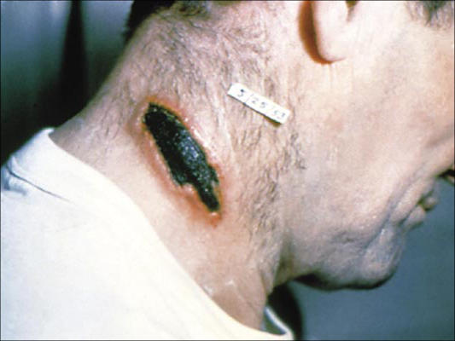

**Cutaneous anthrax**

**Mycobacterial species as Human Pathogens:**

Mycobacteria are acid fast bacilli , non-motile; non- spore forming, non-capsulated bacilli. They need special culture media to grow such as Lowenstein-Jensen.

1. **Lupus vulgaris** (also known as **tuberculosis luposa**) are painful cutaneous [tuberculosis](https://en.wikipedia.org/wiki/Tuberculosis) skin lesions with [nodular](https://en.wikipedia.org/wiki/Nodule_(medicine)) appearance, most often on the face. It is the most common [*Mycobacterium tuberculosis*](https://en.wikipedia.org/wiki/Mycobacterium_tuberculosis) skin infection. The lesions may ultimately develop into disfiguring [skin ulcers](https://en.wikipedia.org/wiki/Skin_ulcer) if left untreated

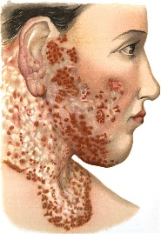 **Lupus vulgaris**

1. **Mycobacteria other than tuberculosis(MOTT):** They are known as non-tuberculous mycobacteria (NTM). Most of them occur in the environment such as water (tap water, water of haemo-dyalysis unit), soil, birds and fish. They are **are not readily transmitted** **from person to person** and are considered as opportunistic pathogens. They have the same morphology of *M.tuberculosis*. According to speed of growth and pigments production they are grouped into slow and rapid growers. Most of them are identified using DNA probes. Diagnosis of MOTT as pathogen depend on **repeated** demonstration of the organisms.The majority of species are resistant to at least one of the first line anti-tuberculous drugs. Species that are significant causes of disease are:
2. **Slow growers: *M.marinum and M.ulcerans*:** grow best at low temperature **31ºC**.It may infect **fish**and can produce superficial **skin lesions**, swimming pool granulomas in man.
3. **Mycobacterium fortuitum, Mycobacterium chelonae, and Mycobacterium abscessus** are environmental mycobacteria that can cause chronic infections of the skin, soft tissues, and lungs. These organisms are characterized by rapid growth on standard media and by lack of pigmentation.

***Mycobacterium leprae*** is responsible for leprosy which is a chronic granulomatous disease ,of skin and nerves, that causes severe deformity in man.

**Morphology:** Modified ZN stain ,they are acid fast bacilli present in parallel bundles.

**Culture:** It has not been cultivated on non-living bacteriologic media. **In vivo** it can be inoculated in foot-pads of mice causing a localgranulomatous lesions develop with limited multiplication of bacilli. **Armadillos** another animal develop **extensive** lepromatous leprosy when inoculated and used to prepare vaccine.

**Leprosy: The incubation period** of the disease is long ranging from **2-5 years.**

**Mode of transmission** : a **close contact** with patients suffering from the severest form of the disease, lepramotous leprosy ,is required to cause infection**. Nasal secretions** are the most likely infectious material. *M.leprae ,* is an obligate intracellular pathogen that multiplied very slowly within the mononuclear phagocytes of the skin and nerves. The resulting damage is responsible for the clinical features of leprosy, which are **loss of sensation** in skin macular lesions, infiltrated **skin nodules** and **nerve infiltration** and **thickening,** with resultant anaesthesia, neuritis, trophic ulcers, bone resorption and shortening of digits.

**The disease is divided in two major types: lepromatous and tuberculoid.**

**Lepromatous leprosy:**This is the severest type, the course of the disease is progressive with nodular skin lesions which when affect the face, the nose collapse giving **lionine face**.

* There is marked sensory loss due to extensive nerve damage.
* Abundant AFB are present in skin lesions, as an intra and extracellular masses known as **globi.**
* **Cell mediated immunity is markedly deficien**t and the skin is infiltrated with suppressor T cells.
* Lepromin skin test is negative.

Although there is  **increased production of serum antibody** yet it is not protective since the bacteria is present inside the macrophages.

**Lepromatous leprosy :lionine face**.

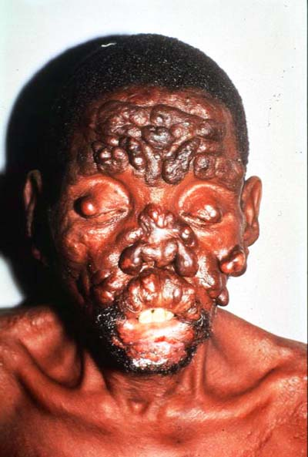

**Tuberculoid leprosy:** The course of the disease is benign and non-progressive , with macular lesions, severe asymmetric nerve involvement of sudden onset with few AFB present in the lesions. Cell mediated immunity is intact and the skin is infiltrated with helper T-cells. **Lepromin skin test is positive**.

**Laboratory diagnosi**s:

**Specimens** are taken from the following areas:

* + - 1. **Scraping from nasal mucosa** and skin.
      2. **Biopsy** of ear lobe skin, from skin nodules and from thickened nerve.
  1. **Direct examination**:

1. Smears are stained with modified ZN stain.
2. PCR test.
   1. **Lepromin skin tes**t: lepromin is a heat-killed suspension prepared from armadillo tissue, injected intradermally to detect delayed hypersensitivity response to *M.leprae*. It is only positive in tuberculoid leprosy. The test is of prognostic value.
   2. **Non-treponemal serologic test** for syphilis frequently yield false positive results in leprosy.

**Actinomycetes**

Gram-positive  bacteria with fungi-like structures, form delicate hyphae or mycelia and aerial filaments.The clinical manifestations of infection are similar to those of a systemic fungal infection.

***Actinomycetes* are true bacteria and not fungi due to:**

1. The lack of mitochondria and a nuclear membrane.
2. Presence of cell wall like gram positive bacteria.
3. Reproduction by Binary fission .
4. Susceptibility to [penicillin](http://www.life.umd.edu/classroom/bsci424/Images/PathogenImages/Penicillin.gif) but not to antifungal chemotherapeutic agents

**Three genera of *Actinomycetes:***

1. *Actinomyces*
2. *Nocardia*
3. *Streptomyces*

**Morphology and Physiology**

* Gram-positive, *Actinomyces* are morphologically similar to [*Nocardia*](http://www.life.umd.edu/classroom/bsci424/PathogenDescriptions/Nocardia.htm)except that *Actinomyces* are non acid-fast. *Streptomyces* are also non acid-fast.
* The *Nocardia* **are aerobic,**grow readily on most bacteriologic and TB media. *Actinomyces* are strictly **anaerobic**, grow slowly in culture.
* They cause infections that are slow to develop and tend to be [**chronic**](http://www.life.umd.edu/classroom/bsci424/Definitions.htm#Chronic).
* *Streptomyces* produce more than 80% of antibiotics used in treatment of infections.

**Epidemiology :**They are normal flora of the upper respiratory, gastro-intestinal and female genital tracts *.*Low virulence potential, only causing opportunistic disease following **disruption of mucosal barriers** by trauma, surgery or infection

**Actinomycosis:** Caused by *Actinomyces israelii* .Occur more commonly as a [chronic](http://www.life.umd.edu/classroom/bsci424/Definitions.htm#Chronic) infection and may occur as acute [pyogenic](http://www.life.umd.edu/classroom/bsci424/Definitions.htm#Pyogenic) infection, that is both [suppurative](http://www.life.umd.edu/classroom/bsci424/Definitions.htm#Suppurative) and [granulomatous](http://www.life.umd.edu/classroom/bsci424/Definitions.htm#Granulomatous). Characterized by multiple [abscesses](http://www.life.umd.edu/classroom/bsci424/Definitions.htm#Abscess) and interconnecting [**sinus tracts**](http://www.life.umd.edu/classroom/bsci424/Definitions.htm#SinusTract) that contain yellow granules of microcolonies called **sulfur granules**. Chronic suppuration results in bone involvement.

**Major skin infections caused by of actinomycoses are :**

1. **Cervicofacial actinomycosis** (most common form): associated with poor oral hygiene, an invasive dental procedure or oral trauma.
2. **Thoracic actinomycosis**: associated with lung aspiration and dissemination into surrounding tissues.
3. **Abdominal actinomycosis**: associated with abdominal surgery or intestinal trauma.

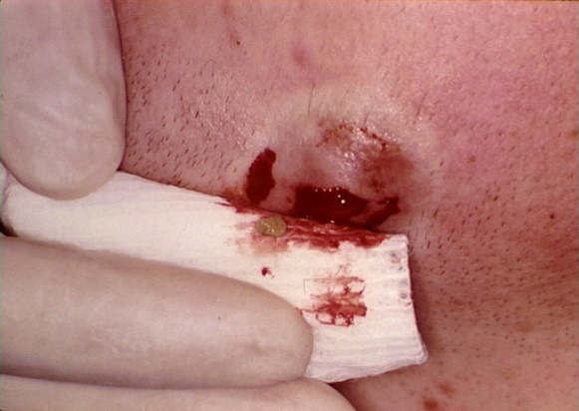

**sulfur granules**

**Laboratory diagnosis:**

**Specimen:** Sulphur granules are crushed and examined by:

1. **Direct examination:** Filamentous branching gram positive bacilli
2. **Culture**: [need](http://www.life.umd.edu/classroom/bsci424/Definitions.htm#Fastidious) enriched media and have slow growth up to two weeks or more.

**Treatment and Prevention:**

1. Surgical [debridement](http://www.life.umd.edu/classroom/bsci424/Definitions.htm#Debridement)  and long-term antibiotic therapy ( penicillin).
2. Maintain good oral hygiene.

**Nocardiosis** :Infection by [*Nocardia brasiliensis*](http://en.wikipedia.org/wiki/Nocardia_brasiliensis) which **are soil** organisms cause **mycetoma** which is a sub-cutaneous lesions.

**Laboratory diagnosis:**

1. **Nocardiae** are weakly acid-fast organisms and can be seen by modified Ziehl Neelsen stains.
2. There are no serological tests.

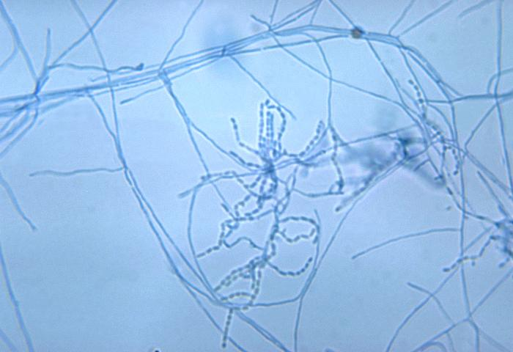

**Actinomycetes**

**Viral:**

|  |  |
| --- | --- |
| 1. *Herpes Simplex Virus* type 1.2 2. *Varicella zoster* 3. *Papilloma virus* | 1. *Small pox* 2. *Measles* 3. *Rubella* |

1. *Herpes Simplex Virus* type 1.2 have the ability to infect epithelial mucosal cells or lymphocytes. The virus then travels up **peripheral nerves** to a nucleated neuron where it may stay for years and be followed by reactivation due to stress, exposure to sunlight and fever.The virus travels back down the nerve axon and recurrence of infection occurs at the **same site** as the initial infection (e.g mucosa) in the form of vesicles containing infectious virus which then heals with no scar formation.

**Transmission** :

***HSV-1***is usually spread **mouth to mouth** (kissing, use of utensils contaminated with saliva) or by **hands** after which the virus may enter the body via any wound or through the eyes.

***HSV-2***is normally spread by:

* 1. **Sexual transmission.**
  2. **Vertical transmission** : perinatal from a mother to infant: Transplacental or during deliveryby a genitally-infected mother.

**Eczema herpeticum**: is found in children with **active** eczema. The virus spreads over the skin at the site of eczema lesions.

**Laboratory diagnosis:** Specimen: Cells obtained **from the base** of the lesion,

1. **Direct examination**:Electron microscopy or ELISA .
2. **Viral isolation**: Grown on tissue culture cells .
3. **Serological diagnosis**: Anti-*HSV* antibodies **(IgM)** is diagnostic for primary infection.
4. ***Varicella zoster*****:**Belong to herpes family*,Zoster* means "girdle" ,it forms a belt around the thorax in many patients. *Varicella* virus causes **two major diseases:**
5. Varicella or Chickenpox, usually in childhood.
6. Herpes zoster or shingles occurs later in life and results from reactivation of an earlier varicella infection.

**Pathogenesis:**

**Varicella or Chickenpox** is a **highly infectious** disease.

* Transmission: by respiratory aerosols or **direct contact with skin lesions.**
* Age: common childhood infection
* The incubation period is :**21 days.**
* Lesions: Vesicles appear as **successive "crops",** so that lesions of different ages are present at **the same time**. The lesions progress from **macule** to **papule** to **vesicle** to **pustule** to **scab**. The rash is most pronounced on the **face,** scalp and trunk **and less on the limbs**.
* Immunity: Varicella is followed by long lasting immunity.

**Herpes zoster or shingles:**

* After the infectious period of chickenpox, the virus may migrate to the ganglia associated with areas in which the virus is actively replicated.
* **Reactivation** usually occurs many years after primary infection and is often associated with immune-suppression of the host, stress or trauma to the spinal cord. The virus travels down the axon and re-infects the dermatome supplied by the sensory ganglian to produce **painful** vesicles on the skin.
* Common sites include the thoracic dermatomes and those supplied by the **trigeminal nerve**. The lesions heal in about two weeks .

1. ***Papilloma virus Human ( HPV)* (Wart viruses) :They are** double-stranded [**DNA**](http://en.wikipedia.org/wiki/DNA) viruses, and **do not** have a [lipoprotein](http://en.wikipedia.org/wiki/Lipoprotein) envelope. They are commonly found in humans.

**Transmission:** By contact, sexual transmission in the case of genital infections;

**Cutaneous warts:** The viruses cause **warts** (benign tumors) of keratinized squamous epithelium (skin).In most people skin warts regress spontaneously .Malignancies are most likely to develop in sun-exposed and traumatized area.

1. ***Smallpox virus* (variola)** cause small pox which is a febrile illnesses in man with a prominent vesicular rash .It is a fatal disease in man that has been eliminated by intensive international vaccination. ***Smallpox virus*** are very large, double-stranded DNA brick-shaped viruses and can be seen by light microscope.
2. Genome: is enclosed within a "core" that is flanked by 2 "lateral bodies".
3. The surface of the virus particle is covered with filamentous protein and have the appearance of a "ball of knitting wool"
4. Envelope: derived from the host cell membranes.

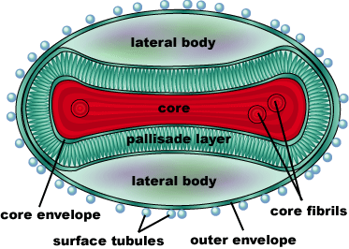

**Small pox virus**

**Small pox :**

* **Incubation :** 10 -12 days.
* **Transmission**:by inhalation (airborn) and by **direct contact** with infected body fluids (such **as bedding or cloth**).
* **Disease:** **cause skin lesions** with **16 to 30% mortality**.
* **Molluscum contagiosum** is a minor infectious warty papule of the skin with a central umbilication, transferred by direct contact, sometimes as a venereal disease. It can cause problem in immuno-compromised hosts.It is caused by a smallpox virus , the Molluscum contagiosum virus.

**Fungal :**

**1- Dermatophytes and Nail fungal infection: Trichophyton and Epidermophyton**

**2- Candida spps.**

**Mycoses**:is a condition in which [fungi](http://en.wikipedia.org/wiki/Fungi) establish [infections](http://en.wikipedia.org/wiki/Infection).

**Classification:** Mycoses are classified according to the [tissue](http://en.wikipedia.org/wiki/Biological_tissue) levels initially colonized

1. **Superficial mycoses** **:**Limited to the outermost layers of the skin and hair.
2. **Cutaneous mycoses:**Restricted to the keratinized layers of the skin, hair, and nails. Unlike the superficial mycoses, host immune responses may be evoked, resulting in pathologic changes expressed in the deeper layers of the skin. The causative organisms are called[**dermatophytes**](http://en.wikipedia.org/wiki/Dermatophyte)**.** The resulting diseases are often called [ringworm](http://en.wikipedia.org/wiki/Ringworm) or [tinea](http://en.wikipedia.org/wiki/Tinea).
   * Causative organisms are: [*Microsporum*](http://en.wikipedia.org/wiki/Microsporum), [*Trichophyton*](http://en.wikipedia.org/wiki/Trichophyton), and [*Epidermophyton*](http://en.wikipedia.org/wiki/Epidermophyton)
3. **Subcutaneous mycoses :**Involve the dermis, subcutaneous tissues, muscle, and fascia.These infections **are chronic** and can be initiated by piercing trauma to the skin, which allows the fungi to enter.These infections are difficult to treat and require surgical [debridement](http://en.wikipedia.org/wiki/Debridement).

***Tinea versicolor***: It is a common skin [infection](http://en.wikipedia.org/wiki/Infection) caused by the [yeast](http://en.wikipedia.org/wiki/Yeast) [*Malassezia furfur*](http://en.wikipedia.org/wiki/Malassezia_furfur) which is normally found on human [skin](http://en.wikipedia.org/wiki/Skin) and only becomes pathogenic under certain conditions such as warm and humid environment, immune or hormone abnormalities.It **is a superficial mycoses** limited to the outermost layers of the skin.

* It affects the skin **of healthy young** people, especially the chest, back, and upper arms and legs. This fungus produces spots that are either lighter than the skin or a reddish-brown.
* *Tinea versicolor* **is not contagious**.

**Cutaneous mycoses**: are restricted to the keratinized layers of skin, hair, and nails and do not invade living tissues. Causative fungi are called **dermatophytes** which produce extracellular enzymes **(keratinases)** that hydrolyze keratin. They are hyphae, reproduce by spore formation (conidia).

**There are three genera of dermatophytes:**

* ***Trichophyton***species (19 species): infect skin, hair and nails
* ***Microsporum*** species (13 species): Infect skin and hair
* ***Epidermophyton floccosum*** : Infect skin and nails

**Sources and modes of transmission:** Dermatophytes have different natural sources and modes of transmission:

1. **Anthropophilic**: Usually associated with humans only;
2. **Zoophilic** :Usually associated with animals; transmission to man by close contact with animals (cats, dogs, cows) or with contaminated products.
3. **Geophilic**: Usually found in the soil, transmitted to man by direct exposure.

Knowledge of the species of dermatophyte and source of infection are important for proper treatment of the patient and control of the source.

**Clinical manifestations**

**Tinea means "ringworm"**a term refer to a variety of lesions of the skin or scalp. The lesions extend radially and heal in the center to form circular lesions hence the name ringworm.

* **Tinea corporis :**Small lesions occurring anywhere on the body.
* **Tinea pedis :**Infection of toe webs and soles of feet**-** "athlete's foot".
* **Tinea unguium :**Infection of the nails.
* **Tinea capitis :**Infection of the head,frequently found in children .
* **Tinea cruris :**Infection of the groin, perineum or perianal area.
* **Tinea barbae :**Ringworm of the bearded areas of the face and neck.
* **Tinea circinata :**Ringworm of non hairy skin.

They are all **contagious**, transmitted by direct or indirect contact.

**Candidiasis :**Commonly called **yeast infection** or **thrush**, caused by [*Candida*](http://en.wikipedia.org/wiki/Candida_%28genus%29) species, of which [*Candida albicans*](http://en.wikipedia.org/wiki/Candida_albicans) is the most common. *Candida albicans* is an **endogenous** organism. It is present as a commensal in the mouth, gut, and vagina .It could be present as pathogenic organism when a patient has some alteration in cellular immunity, normal flora or normal physiology.

**Predisposing factors for the overgrowth of *Candida:***

1. External use of irritants.
2. Hormonal or physiological disturbance as in pregnancy,the use of oral contraceptives [,hormone replacement therapy](http://en.wikipedia.org/wiki/Hormone_Replacement_Therapy) and infertility treatments
3. [Diabetes mellitus](http://en.wikipedia.org/wiki/Diabetes_mellitus)
4. Extensive use of [antibiotics](http://en.wikipedia.org/wiki/Antibiotics).
5. Immunosuppression.
6. Invasive procedures, such as cardiac surgery and indwelling catheters, produce alterations in host physiology and some of these patients develop *Candida* infections

**Candidiasis can be superficial,** causing local [inflammation](http://en.wikipedia.org/wiki/Inflammation) ,symptoms include severe [itching](http://en.wikipedia.org/wiki/Itching), [burning](http://en.wikipedia.org/wiki/Burning), and irritation such as:

1. Interdigital.
2. Between skin folds.
3. Paronychia (infection of the nail).
4. Chronic mucocutaneous candidiasis which is associated with T-cell deficiency

**Laboratory diagnosis:** Specimen: nail clippings or material from cutaneous or mucocutaneous lesions.

**A- Direct microscopic examination:**

1. KHO wet mount preparation to detect budding yeast, hyphae, pseudo-hyphae.
2. Smears stained with gram: oval , budding yeast cells and **pseudo-hyphae**.
3. On Sabouraud dextrose agar,at 37ºC for 1-2 days .Colonies are creamy with yeast odor. Candida albicans are differentiated from non pathogenic species by :
4. **Germ tube test :** Invasive form of the organism produce germ tubes (pseudo-mycelia) when incubated **in serum** at 37ºC for **1-2 hours**.
5. Spores may be formed on the pseudo-mycelium. These are calledchlamydospores and can be used to identify different species of *Candida*.

**Mycetoma or**  **Madura foot**

* A mycotic infection of humans and animals caused by a number of different fungi and actinomycetes (bacteria) characterized by draining sinuses and granules **.**
* The disease results from the traumatic implantation of the aetiologic agent and usually involves the cutaneous and subcutaneous tissue, fascia and bone of the foot or hand. Sinuses discharge sero-sanguinous fluid containing the granules which vary in size, colour and degree of hardness, **depending on the aetiologic** **species**, and are the hallmark of mycetoma.
* World-wide distribution but most common in **bare-footed** populations living in tropical or subtropical regions. It rarely affects hand and buttocks.

There are two known forms of mycetoma:

* 1. **Bacterial mycetoma caused by *Nocardia******.brasiliensis***
  2. **Fungal mycetoma:** **caused by** [***Madurella mycetomatis***](http://en.wikipedia.org/w/index.php?title=Madurella_mycetomatis&action=edit&redlink=1)

**Laboratory diagnosis:** can differentiate between bacterial and fungal aetiology of mycetoma.

* + 1. **Direct examination:**

1. Macroscopic examination: Tissue biopsy or sero-sanguinous fluid containing **granules** which are yellow to **white** in bacteria, **black** with fungi
2. Microscopical examination: Examined using either 10% KOH and tissue sections should be stained using Haematoxylin and eosin (H&E).**Thick** hyphae and spores are diagnostic of fungi, while fragmented filaments are diagnostic of bacteria

**B-Culture:**

1. On Sabouraud's dextrose agar, incubation at room temperature is essential to isolate fungi.
2. Blood agar isolate bacterial agent.

**C- Serology:** no commercially serological procedures are available for the diagnosis of mycetoma.

**Table - Differences between bacterial and fungal mycetoma.**

|  |  |  |
| --- | --- | --- |
| **Test** | **Bacterial** | **Fungal** |
| **1-Direct Examination**  **A-Macroscopic :Granules**  **B-Microscopical: hyphae** | **yellow to white in bacteria,** | **black with fungi** |
| **fragmented filaments** | **Thick hyphae and spores** |
| **2-Culture** | **Blood agar (37°c)** | **On Sabouraud's dextrose agar, incubation at room temperature** |
| **3-Serology**: no commercially serological procedures are available | | |