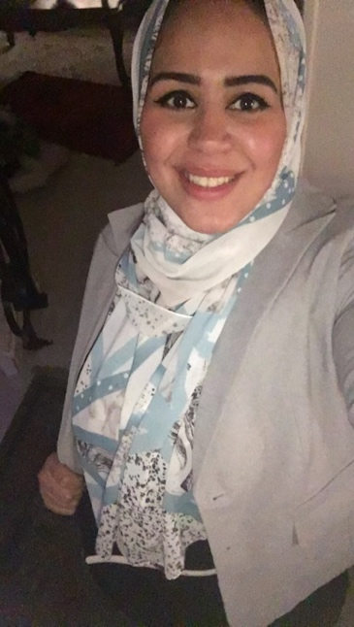
Dr / Reem Salah Abuelanin
Assistant Lecturer of General Surgery department
O6U – Faculty of Medicine
Email: Reem.s.mohammed@hotmail.com
Subject: Operative 6th year medical students
Channel Playlists:
https://youtube.com/playlist?list=PLvKdInwvkNwoPJXjHmSv86X-1xvWO07kx
https://youtube.com/playlist?list=PLAtwANQUCQaIpjTNaCQHt8whsvmHoRe3R

- Amputation: https://youtu.be/_5NWhue9tMo
Question (1)
Most common cause of amputation:
A: Trauma
B: Diabetic foot infection
C: Tumor
D: Thermal injuries
Answer: B
Question (1)
Types of lower limb amputation include:
A: Symes amputation
B: Chopart’s amputation
C: Below knee amputation
D: All the above
Answer: D

- Submandibular excision: https://youtu.be/vig6kpX2X8E
Question (1)
All the following must be preserved during submandibular gland excision except:
A: Facial artery and vein
B: Hypoglossal nerve
C: Marginal mandibular nerve
D: Lingual nerve
Answer: A
Indication of submandibular sialoadenectomy include all the following except:
A: Chronic sialadenitis
B: Stone in the gland or the duct
C: Acute sialadenitis
D: Salivary gland tumors
Answer: C
- Thyroidectomy: https://youtu.be/uFLjB7Vhng4
Question (1)
The Kocher incision is done at:
A: At suprasternal notch
B: 2cm above suprasternal notch
C: Below the angle of the mandible
D: At the thyroid cartilage
Answer: B
Question (2)
Indications of Thyroidectomy:
A: Multinodular goiter.
B: Solitary Nodule.
C: Toxic nodular goiter.
D: All the above.
Answer: D
- Parotidectomy:
Part A: https://youtu.be/1pHrVQ04J0k
Question (1)
The nerve that could be injured during parotidectomy is:
A: Lingual nerve
B: Facial nerve
C: Mandibular nerve
D: Infraorbital nerve
Answer: B
Part B : https://youtu.be/FNq8z9080tU
Question (2)
Types of Parotidectomy:
A: Superficial Parotidectomy
B: Total Parotidectomy
C: Radical Parotidectomy
D: All the above.
Answer: D
- Mastectomy: https://youtu.be/8OSdun0hvNw
Question (1)
Injury of which nerve can cause winging of the scapula:
A: Pectoral nerve
B: Nerve to latissimus dorsi
C: Long thoracic nerve
D: Thoracodorsal bundle
Answer: C

Question (2)
Skin flaps are dissected in the following dissection except:
A: upper flap dissected till the second intercostal space
B: lower flap dissected till the inframammary fold
C: medially dissected till the sternum
D: laterally till the latissimus dorsi
Answer: A
- Esophagectomy: https://youtu.be/PZL5no9Z1kI
Question (1)
Indications of Esophagectomy:
A: High-grade dysplasia
B: cancer esophagus
C: Megaesophagus (achalasia)
D: All of the above
Answer: D
Question (2)
Types of esophageal replacement surgery:
A: Gastric pull up
B: colon replacement
C: Jejunum free flap
D: All of the above
Answer: D
- Lipoma excision: https://youtu.be/kNgNprk-lI4
Question (1)
The solution used to sterilize the skin is:
A: Betadine solution
B: Hydrogen peroxide
C: methylene blue
D: glycerin magnesia
Answer: A
Question (2)
Regarding the technique of lipoma excision: which of the following is the correct answer:
A: closure of the wound is done with non-absorbable sutures for subcutaneous tissue.
B: closure of the wound is done with absorbable sutures for subcutaneous tissue.
C: closure of the wound is done with non-absorbable sutures for the skin.
D: closure of the wound is done with non-absorbable sutures for subcutaneous tissue and skin.
Answer: B

- Varicose veins: https://youtu.be/WnT80DoCE0g
Question (1)

Modalities of treatment of varicose veins:
A: Conservative
B: Ablation
C: Injection sclerotherapy or surgery
D: All of the above
Answer: D
Question (2)

Types of Surgical treatment :
A: Trendelenburg operation
B: Stripping of Great Saphenous vein
C: Endoscopic Sub-facial ligation
D: All of the above
Answer: D
- Chest tube insertion: https://youtu.be/p69ucZByT44
Question (1)
Indications of chest tube insertion include:
A: Pneumothorax
B: Hemothorax
C: Post-Thoracotomy
D: All of the above
Answer: D
Question (2)
Regarding technique of Chest tube insertion: which of the following is correct
A: skin incision should be parallel to the ribs
B: Skin incision should be 7-10 cm.
C: Skin incision should be perpendicular to the ribs
D: Skin incision should be parallel to the sternum.
Answer: A

- Femoral artery exposure: https://youtu.be/B3M774U90Q0
Question (1)
To expose the femoral artery where is the incision made:
A: 4 cm distal to the midpoint of inguinal ligament
B: 2 cm above the inguinal ligament
C: 4 cm lateral to the pubic tubercle
D: just below the inguinal ligament
Answer: A

