Student guide
M4 2024-2025 First term

- Contents:
- Guide lines (why P.B.L. “Problem Based Learning”) added to integrated system in October 6 university faculty of medicine (what the student & tutor will do this term) , (modules in this term & their general objectives)
- Schedule for lectures , practicals , cases ( small group teaching) , skill lab , & exams
- Rubrics for grading assignments and presentations
- Portfolio template ( to be completed by each student and tutors and department members put the marks and be submitted to tutors by end of each module )
- Cases ( with objectives in tutor guide and without objectives in student guide )
- PBL Philosophy:
In a world where available information is growing exponentially, we believe that the most important thing a student needs to know is how to learn. So the main learning goals of the PBL are a framework for looking at concepts, skills, and abilities and help guide the creation of personalized student curriculum. PBL offers unique environments where students can flourish as individuals within a community of learners.
- PBL Process:
The core of the PBL process is the tutorials that will be held once weekly beside the practical sessions and the interactive lectures. In each tutorial there will be a case scenario that is delivered to the students, where they collaborate together through the seven jumps process to point out the possible problems present in the case and to find out the intended learning objectives need to be known through this case. In the second tutorial, they will discuss the objectives of the case after self study, and a new case will be delivered. In PBL process the role for lectures aim at clarification of complicated areas of information or to integrate different areas of information. Practical sessions and clinical skill lab are included as educational activities in BPL. They act as tools for the students to gain the needed psychomotor skills and to attain the professional attitude and behavior.
- Student role:
The student is the center of the learning process in PBL. Students will depend on themselves in finding out the learning objectives by brain storming in the case study session. Then they will go home and study and search in the texts for the information of the objectives they got. Then the following session they should try to present the information they gazered and summarized to their students in an easy palatable way. In BPL the students have to work hard, prepare themselves well for every tutorial group meeting, collaborate with their colleagues and practice team work. They also will have their reflection about the process, their colleagues and the tutor.
- Tutors role:
- The tutor will work as a facilitator more than traditional teacher who delivers all the information to the students. Tutors role is to stimulate and motivate the students to learn and to search for the information and knowledge. During the case they will guide the students and redirect them towards the intended learning objectives. The tutors share in the assessment process. Moreover, the tutor together with the students has the responsibility of setting the roles of the tutorial session.
- The tutor will receive guide information for the objectives in each case from the departments at least one week before the case is to be discussed, he should read them and then in the discussion of the case he should see if the students had fulfilled all the needed items so as to approve their work or they need to search more for certain items and get them so as to complete their work completely or they got more or un needed items they should discard them. By the end of the cases of the module students will have their hand out covering all items needed in the objectives they searched for
- All staff members should have their official mails done by the beginning of the academic year so as good communication may be applicable and to facilitate uploading of their lectures every Wednesday of each week

- In each session one of the students will be the reader ( the one who reads the case ) and another one will be the writer ( the one who writes the objectives on the board after brain storming of the students with the tutor and collect them after that )
- In session (1) (week 1)
- One case will be red by the students
- They make brain storming with each other and with the tutor to get the objectives the case is talking about. they will go home to search for them and make presentation about them the coming session
- Weeks for reading of the cases and discussion of the objectives are written above each case
- The presentation have certain rubrics the tutor try that the students stick more and more to them each presentation then at the last presentation of the module they will have certain mark among their portfolio total mark about:
- The presentation they showed along the module and their share in the discussions and preparation of the work needed ( see professional behavior sheet included) (the mark is given by the tutor )
- After they finish the presentation in each session they will read the following case and brain storm to get the objectives that they will go home to prepare them as presentation in the coming case session and so on all the sessions
- If the case is long its presentation by the students may take two weeks not one week to ensure that the students presented the objectives in the case in a good way

- All students are to make their Emails in the first week try to login to thr LMS so as to be able to reach the following:
- Lectures
- Videos
- Presentation
- On line exams formative questions

- Scoring Rubric for Presentations:
Category | Scoring Criteria | Total Points | Score
Organization  (15 %) | Were the main ideas presented in a clear manner? | 5
Organization  (15 %) | Information is presented in a logical sequence. | 5
Organization  (15 %) | Presentation appropriately cites requisite number of references. | 5
Content  (45 %) | - The Introduction is attention-getting,  - It lays out the problem well,  - It establishes a framework for the rest of the presentation. | 5
Content  (45 %) | Technical terms are well-defined in language that is appropriate for the target audience. | 5
Content  (45 %) | The Presentation contains accurate information. | 10
Content  (45 %) | The material included is relevant to the overall message/purpose. | 10
Content  (45 %) | Appropriate amount of material is prepared, and the points made reflect well their relative importance. | 10
Content  (45 %) | There is an obvious conclusion summarizing the presentation. | 5
Presentation  (40 %) | Speaker maintains good eye contact with the audience and is appropriately animated (e.g., gestures, moving around, etc.). | 5
Presentation  (40 %) | Speaker uses a clear, audible voice. | 5
Presentation  (40 %) | Delivery is poised, controlled, and smooth. | 5
Presentation  (40 %) | Good language skills and pronunciation are used. | 5
Presentation  (40 %) | Visual aids are well prepared, informative, effective, and not distracting. | 5
Presentation  (40 %) | Length of presentation is within the assigned time limits. | 5
Presentation  (40 %) | Information was well communicated. | 10
Score % | Total Points | 100%

Steps to register on the Moodle
e-learning website for Faculty of Medicine
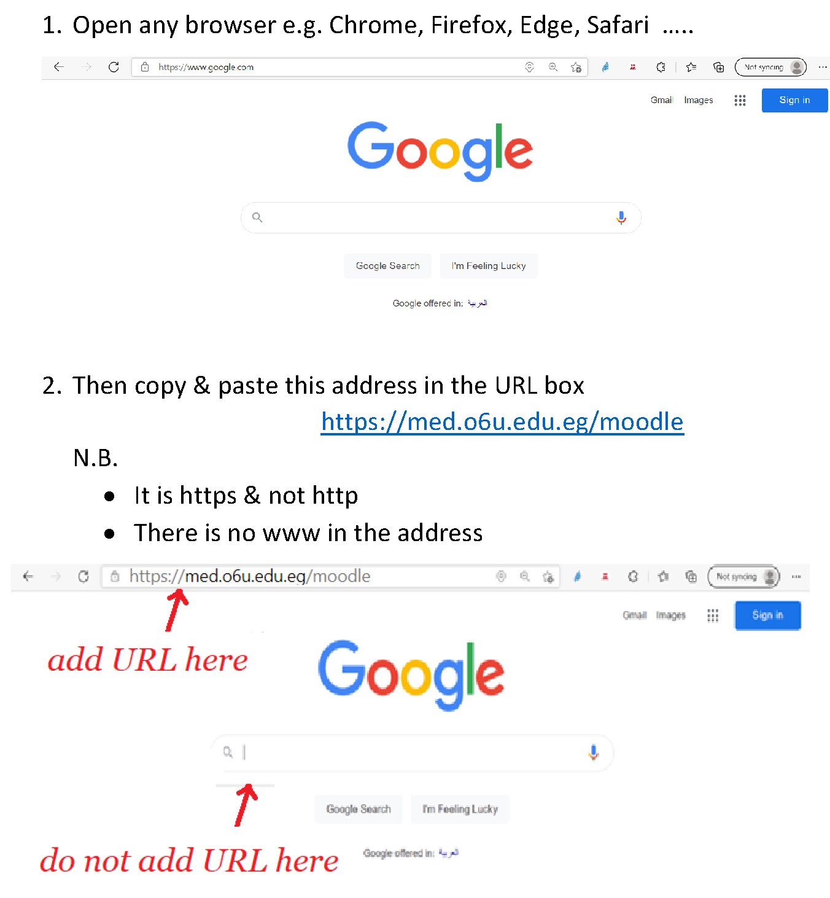

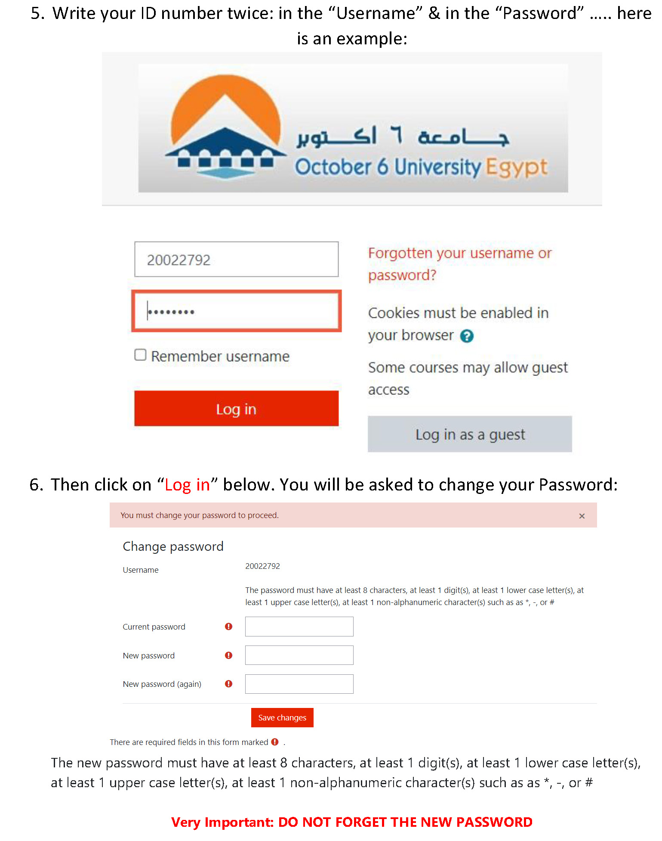
How to enroll yourself in a Module?
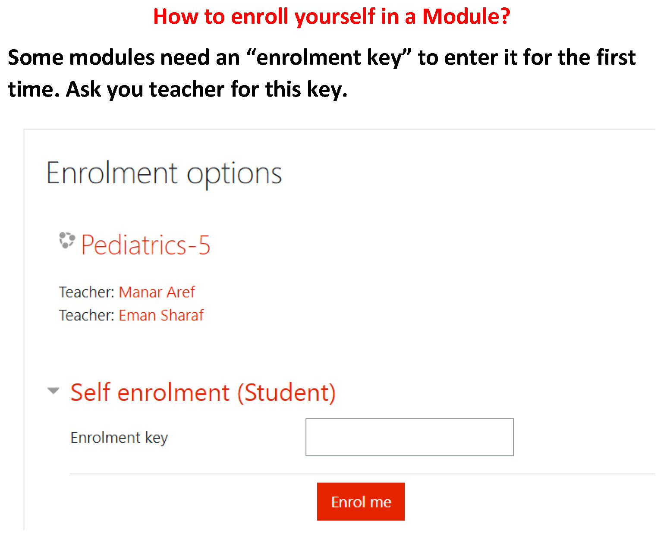

Professional Behavior of student in the case checklist
Students Name: ....................................
Date: ...................................................... End of module (Summative): ...........................
Module title: .....................................................................
Student’s Signature :............................ Tutor’s Name:.....................................................

Criteria | Scale: | Comments
Criteria | 1 and 2 is unsatisfactory,  3, 4 and 5 is satisfactory performance | Comments
Preparation:  Is well prepared with relevant information, uses a variety of references and summarizes key points | 1 2 3 4 5
Critical thinking:  Identifies problem, analyzes problem, suggests possible reasons for the problem, helps group to formulate learning objectives | 1 2 3 4 5
Participation:  Participates actively, talks on turn and listens attentively to others | 1 2 3 4 5
Communication Skill & Group Skills:  Respects tutor and colleagues, communicates well uses appropriate language, accepts feedback and responds appropriately.  Contributes to group learning, shares information with others, demonstrates sensitivity to views and feeling of others, takes on assigned tasks willingly | 1 2 3 4 5
Presentation skills:  Presents the information relevant to the learning objectivse of the case, explains clearly the reasoning process with regard to solving the problem | 1 2 3 4 5
Overall | SATISFACTORY | UNSATISFACTORY

-The students portfolio (October 6 university - faculty of medicine - 2024 - 2025):
Portfolio :
It is a collection of student work , reflections , and educational experience done and arranged by the student for documentation and assessment.

Purpose of portfolio :
It is formed to monitor the student progress ,, assess the student achievement , and determine the student grades.

Goals
-Show learning progress over time
-Provide greater motivation for students
-Increase self assessment skills
-Encourage reflective learning
-Increase tutor student collaboration

Module :
Student name :
ID:
Level:
Academic year :
First term / Second term :

Task | Monitored by | Signature | Mark
-CV of student  -Attendance  -List of Cases taken or seen in the module  -Objectives detected by brain storming  -Presentation infront of colleagues against rubrics  -your reflection concerning the sessions, cases , objectives , and presentation | Tutor |  | 20%
-Topics of Lectures taken in the module  -topics of practicals and laboratories taken in the module  -Skills achieved n this module  -Number of formative exams done  -Your reflection concerning the lectures , practicals , skill labs , and formative exams | -Department member  -Department member  -professor in the skill lab  -professor in the lecture  -Department member |  | 10%
Task needed by department ………….  or assignments or research work or video making | -Department member |  | Mark for all departments sharing in module 25%
Task needed by department ………….  or assignments or research work or video making | -Department member |  | Mark for all departments sharing in module 25%
Task needed by department ………….  or assignments or research work or video making | -Department member |  | Mark for all departments sharing in module 25%
Points of strength you had in this module  (what you need to do using what you knew or what could have been better in your work after your knowledge ) | Tutor |  | 10%
Points of weakness in this module and your sight to correct them | Tutor |  | 5%
Describe your study day  (what you tried to learn , how your learning influenced your practice , the most important thing you learnt in this module) | Tutor |  | 10%
Meeting with staff member (what was the objective and what was the result ) | Staff member |  | 5%
Have you visited Alex (the talking patient robot , and SECTRA table ) (If YES please say how was your journey and if NO please say why ) | Tutor |  | 3%
Describe your group work with your colleagues (Team Based Learning ) | Tutor |  | 10%
Any activities you have done | Tutor |  | 2%

OSCE | OSPE | END MODULE | CONTNUOUS ASSESSMENT | MID MODULE | FOURTH YEAR
OSCE | 38 marks total  -slides electronic | 50 marks total  40 MCQ  10 SAQs electronic | 10 marks total  1.5 attendance small groups  1.5 attendance cases  4 presentation  3 portfolio | 27 marks electronic | CARDIOLOGY SM402 ( 125)
OSCE | 23 marks total  -slides electronic | 30 marks total  25 MCQ  5 SAQs electronic | 4 marks total  1 attendance small groups  1 attendance cases  1 presentation  1 portfolio | 18 marks total  15 marks electronic exam  3 marks history | CHEST SM403 (75)
OSCE | 38 marks total  -slides electronic  18 ospe electronic  20 osce clinical | 50 marks total  40 MCQ  10 SAQs electronic | 8 marks total  3 attendance sections  1.5 attendance cases  2 presentation  1.5 portfolio | 29 marks electronic | PEDIATRICS 401  ( 125)
OSCE | 38 marks total  -slides electronic and practical | 50 marks total  40 MCQ  10 SAQs electronic | 10 marks total  1.5 attendance sections  1.5 attendance cases  4 presentation  3 portfolio | 27 marks electronic | MUSCULOSKELETAL SM404 ( 125)

Cases for the fourth year students modules
(Chest , CVS, Musculoskeletal , pediatrics)
Cases for Musculoskeletal module:
- Lupus Nephritis
- A 45-year-old woman with systemic lupus erythematosus (SLE) presents to the emergency department with complaints of headache and fatigue.
- Her prior manifestations of SLE have been arthralgias, hemolytic anemia, malar rash, and mouth ulcers, and she is known to have high titers of antibodies to double stranded DNA as well as anti Sm antibody.
- She currently is taking prednisone, 5 mg daily, and hydroxychloroquine, 200 mg daily.
- On presentation, she is found to have a blood pressure of 190/110 with a heart rate of 98 beats/min.
- A urinalysis shows 25 red blood cells (RBCs) per high-powered field with 2+ proteinuria.
- Her blood urea nitrogen is 88 mg/dL, and creatinine is 2.6 mg/dL (baseline 0.8 mg/dL).
- She has not previously had renal disease related to SLE and is not taking nonsteroidal anti-inflammatory drugs.
- She denies any recent illness, decreased oral intake, or diarrhea.
What is the most appropriate next step in the management of this patient?
- Initiate azathioprine ( immune suppressing agent).
- Prepare for kidney transplantation.
- Initiate high-dose steroid therapy ( pulse steroid therapy).
- Initiate plasmapheresis ( technique used to wash out the harmful antibodies)
- Withhold all therapy until renal biopsy is performed
- Explanation:
The answer is C.
- This patient is presenting with acute lupus nephritis with evidence of hematuria, proteinuria, and an acute rise in creatinine. Together with infection, nephritis is the most common cause of mortality in systemic lupus erythematosus (SLE) and warrants prompt immunosuppressive therapy.
- It is important to assess for other potentially reversible causes of acute renal insufficiency, but this patient is not otherwise acutely ill and is taking no medications that would cause renal failure.
- The urinalysis shows evidence of active nephritis with hematuria and proteinuria. Even in the absence of red blood cell casts, therapy should not be withheld to await biopsy results in someone with a known diagnosis of SLE with consistent clinical presentation and urinary findings.
- The mainstay of treatment for any life-threatening or organ-threatening manifestation of SLE is high-dose systemic glucocorticoids.
- Addition of cytotoxic or other immunosuppressive agents (cyclophosphamide, azathioprine, mycophenolate mofetil) is recommended to treat serious complications of SLE, but their effects are delayed for 3–6 weeks after initiation of therapy, whereas the effects of glucocorticoids begin within 24 hours.
- Thus, these agents alone should not be used to treat acute serious manifestations of SLE. Cyclophosphamide and not azathioprine in combination with steroid therapy has been demonstrated to prevent development of end-stage renal disease better than steroids alone.
- Plasmapheresis is not indicated in the treatment of lupus nephritis but is useful in cases of severe hemolytic anemia or thrombotic thrombocytopenic purpura associated with SLE.
- Finally, this patient has no acute indication for kidney transplantation and, with treatment, may recover renal function.
Objectives:

Case Two: (
Rheumatoid Arthritis.
- A 32-year-old female presents with episodes of pain, stiffness, and swelling in both hands and wrists for approximately 1 year.
- The episodes last for several weeks and then resolve.
- More recently, she noticed similar symptoms in her knees and ankles.
- Joint pain and stiffness are making it harder for her to get out of bed in the morning and are interfering with her ability to perform her duties at work.
- The joint stiffness usually lasts for several hours before improving. She also reports malaise and easy fatigability for the past few months, but she denies having fever, chills, skin rashes, and weight loss.
- Physical examination reveals a well-developed woman, with blood pressure 120/70 mm Hg, heart rate 82 bpm, and respiratory rate 14 breaths per minute.
- Her skin does not reveal any rashes.
- Head, neck, cardiovascular, chest, and abdominal examinations are normal. There is no hepatosplenomegaly.
- The joint examination reveals the presence of bilateral swelling, redness and tenderness of most proximal interphalangeal (PIP) joints, metacarpophalangeal (MCP) joints, the wrists, and the knees.
- Laboratory studies show a mild anemia with hemoglobin 11.2 g/dL, hematocrit 32.5%, mean corpuscular volume (MCV) 85.7 fL, white blood cell (WBC) count 7.9/mm3 with a normal differential, and platelet count 300,000/mm3.
- The urinalysis is clear with no protein and no red blood cells (RBCs). The erythrocyte sedimentation rate (ESR) is 75 mm/h, and the kidney and liver function tests are normal.
- The diagnosis is
- Gout
- Scleroderma
- Systemic lupus
- Rheumatoid arthritis
- The diagnostic test of choice for this condition is
- Anti CCP antibody
- Anti Sm antibody
- Antidouble stranded DNA
- Anti Scl-70 antibody
Summary: This is a 32-year-old woman with a 1-year history of symmetric polyarticular arthritis and morning stiffness. Joint examination reveals the presence of bilateral swelling, redness and tenderness of her PIP joints, MCP joints, wrists, and knees. She has a mild normocytic anemia with an otherwise normal complete blood count (CBC). Urinalysis, renal, and liver function tests are normal. The ESR is elevated, suggesting an inflammatory cause of her arthritis.
Objectives
Cases for the module chest: (
Case-based learning SM 403 2024/2025
A 65-year-old man an ex-smoker after 20 years of cigarette smoking one pack per day worked in mining, engineering, and machine repair. He was presented to the respiratory clinic with intermittent dull right-sided chest pain and breathlessness for the last month, with no apparent trigger. Two weeks before the presentation, he noticed a deterioration in his exercise tolerance. He now developed breathlessness on walking or climbing more than five stairs and was sleeping on three pillows, accompanied by loss of appetite and weight. He complained of a dry irritating cough that does not respond to antitussive, without hemoptysis but he usually hears chest wheezes, especially with effort. On shaking hands, his fingers showed second-degree clubbing.
The chest examination showed a barrel-shaped chest with limited respiratory movement over the right hemithorax and low TVF. On percussion, there was dullness over the right infrascapular area. On auscultation, there was decreased intensity of HVB over the right infrascapular area with expiratory rhonchi all over the chest.
The presenting chest X-ray demonstrated well-defined right-upper and middle-lobe peripheral opacification with an associated moderate right-sided pleural effusion.
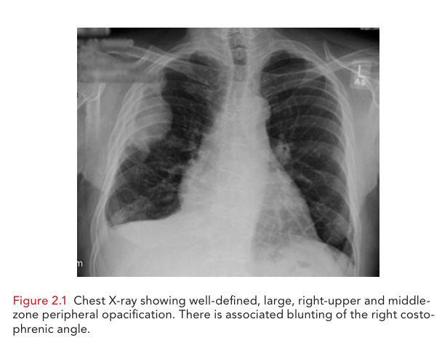
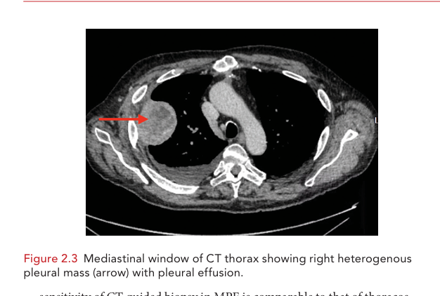
Cytology from pleural fluid samples showed neutrophil-rich fluid, with no malignant cells therefore the pulmonologist decided to obtain a Pleural biopsy which was conducted via thoracoscopy (medical thoracoscopy or video-assisted thoracoscopic surgery [VATS] under general anesthesia to visualize the pleura, take a biopsy from the affected areas, and drain pleural fluid.
Thoracoscopy was conducted and macroscopic evaluation showed few pleural plaques and some areas of pleural inflammation. There were some areas of fine pleural nodularity, highly suggestive of malignant disease. A large vascular and anterior pleural mass adjacent to the diaphragmatic pleura was identified.
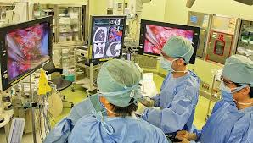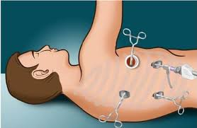
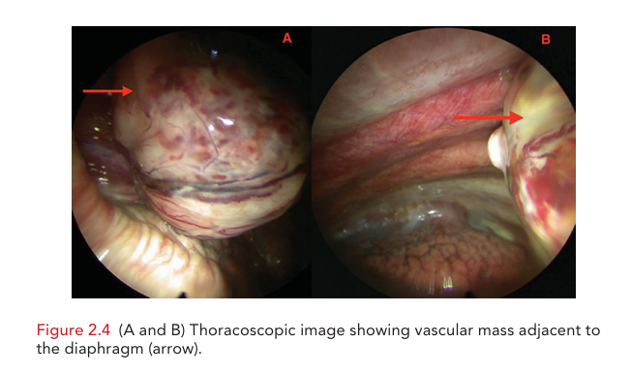
Histopathological examination showed a malignant spindle cell tumor consistent with sarcomatoid mesothelioma
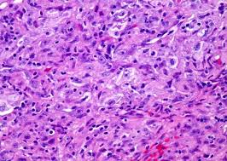
The case was advanced staged of mesothelioma (due to chest wall invasion and mediastinal node involvement), and histopathology was consistent with sarcomatoid mesothelioma.
An intercostal tube was inserted for pleural fluid control according to the patient's choice. Treatment with combination chemotherapy has started.
After two cycles, he was presented with a persistent fever up to 40° with turbid pleural fluid (empyema), for which a combination of 3 systemic antibiotics was started immediately empirically and the pleural fluid sample was sent for bacteriological examination, Gram stain, culture, and sensitivity.
The results revealed mixed bacterial infection with Methicillin-resistant staphylococcus aureus MRSA sensitive to antibiotics: Vancomycin, linezolid, and levofloxacin were modified to the prescribed antibiotics started empirically. The management plan was completed in 2 weeks with a good response to the combination of antibiotics and the intercostal tube draining was removed.
Follow-up imaging showed an increase in the size of the pleural-based mass, which made the likelihood of benefit from further chemotherapy very low, in addition to a decline in performance status. A decision was made to stop chemotherapy and to direct the management plan to increase his quality of life through supportive care.
MRSA microscopic picture and culture on blood agar
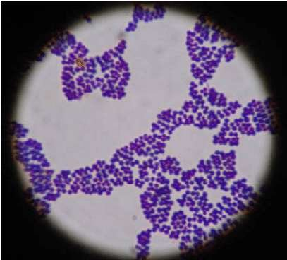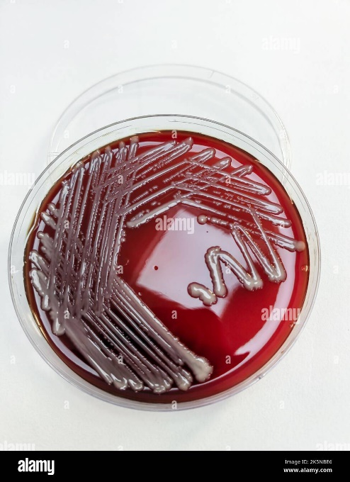

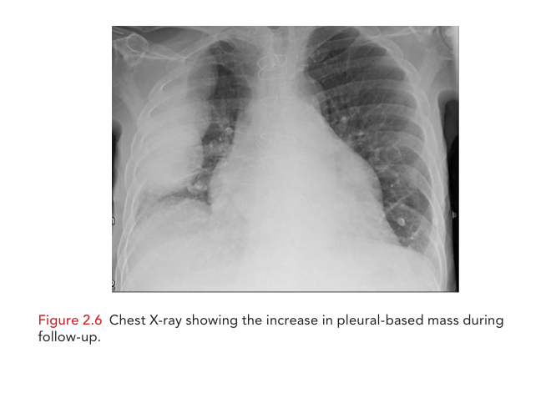

Objectives:

Cases for pediatric module :
- Case Scenario (I)
Objective

Setting: outpatient clinic
Complaint: my child hasn’t passed stools
A 2 day old baby, born by spontaneous vaginal delivery at 39 weeks to G1,P0 mother with insignificant prenatal history, has not passed stools yet.
According to the mother the baby abdomen seems to be distended, and he vomited twice. The vomit was greenish color. The mother thought this was normal for newborn to vomit.
On Physical Examination:
- Baby alert, crying
- Chest: clear to auscultation bilaterally
- Hears sounds are normal with no murmurs
- Abdomen is distended
- Rectum is patent
Abdominal X ray Shows: Bowel obstruction in the small bowel

- Which of the following is the most likely diagnosis of this patient?
- Hirschsprung disease
- Duodenal atresia
- Meconium ileus
- Intussusception
- Imperforate anus
2) What is the next best step in management of this patient?
- NPO
- Nasogastric Tube
- IV fluids
- Replace electrolytes
- Water soluble contrast enema
- All the above

3) What is the next step in diagnosis of this patient?
- Sweat chloride testing
- CFTR gene testing
- CT abdomen
- Nasal potential difference
Answers:
- Answer is C: Meconium ileus
Meconium ileus is present in newborn when the first stool (meconium fails to pass and accused obstruction in intestines. This presents with abdominal distension bilious vomiting and failure to pass stools
The abdominal Xray of meconium ileus shows an obstruction small intestine
Hirschsprung’s disease is failure of nerves to innervate the last portion of colon, leading to failure to pass meconium in first 48 hours of life .it leads t abdominal distension and vomiting. However, abdomen x-rays will show a thin last segment of colon with a Megacolon before it.
Necrotizing enterocolitis will show pneumatosis intestinalis ion radiography. The child will have poor feeding, temperature instability and may have blood stools
Intussusception usually occurs in children, infants or toddlers who have Intermittent COLICKY Abdominal pain at 20 -30 min. intervals; the patient will get into fetal position to help relieve pain.
Target sign on X rays is pathognomonic
Imperforate anus rules out after local examination and following delivery of the baby

- Answer F: All the above
The best initial therapy for a child with meconium ileus obstructing intestines is to make the child NPO, replace fluid losses m provide electrolytes with IV fluid s and decompress bowel proximal to terminal ileum. The most definitive step is to give child an enema with hypertonic water-soluble contrast, which will draw fluid into the bowel and cause meconium to be washed out.

-------------------------------------------------------------------------------------------------------------------

Objectives:

Case II
Setting: clinic
Complaint: I think the baby sitter slapped my daughter face
HPI: a 5year old girl is brought to doctor office. the mother is worried that her babysitter slapped baby across her cheeks. She is concerned about red marks on cheeks and upper extremities. The girl has a lacy rash across upper extremities and trunk. The mother states it has been there for 4 days.
Vital signs: HR 85 per min. RR 20/min, Temp. 38.5°C
Physical Exam:
- A red rash on cheeks
- Lacy rash on upper arms, trunk, and legs (figure below)
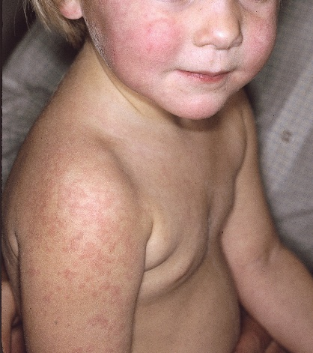
- Pain with palpation of hips and elbows
What is the most likely diagnosis?
- Measles
- Erythema infectiosum
- Rubella
- Varicella
Erythema infectiosum is a viral exanthem secondary to Parvovirus B 19 infection
The child will present with a red “slapped check “look with reticular rash on extremities and sparing palms and soles. Varicella present with vesicles. measles, rubella will not present slapped check appearance. Diagnosis is based on clinical finding and treatment is supportive.
- Nature of Parvovirus?
- Presentation of Parvovirus in pregnant and children??

Cases for module Cardiology:
Cardiology Cases:
Cardiac myxoma
Dyslipidemia
Vasospastic angina
Aortic dissection with tamponade

Case One:
A 24 - year - old woman is referred to A & E following c/o of dyspnea and non-specific chest discomfort in addition to mild dizziness. She also had transient difficulty of speech for few minutes. She tells you that 2 days earlier she had transient visual loss in her right eye (‘like a black curtain coming down over the eye’ ) which lasted for a few minutes before recovering. She is normally fit, well and has no past medical history of note. She takes the oral contraceptive pill. She has not experienced any palpitations, breathlessness, or chest pain before. On physical examination her temperature is 37.2 ° C; blood pressure 105/75 mmHg; pulse 80 bpm, regular. The JVP is not raised. Her apex beat is not displaced. Her heart sounds are normal. There is a faint diastolic rumbling murmur heard at the apex in left lateral position. All peripheral pulses are normal and there are no bruits. The lung fields are clear. Abdominal examination is unremarkable with no hepatosplenomegaly. A neurological examination reveals an upper right quadrantanopia in the visual fields but no other abnormality. There are no sensory or coordination abnormalities. ECG shows atrial fibrillation and echocardiography revealed a mass in the left atrium
- What are your differential diagnoses?
- What other investigations are needed?
- What is the main microscopic and macroscopic pathology of the condition?
- What are the complications that may arise from this condition?
- Outline the treatment of this condition
Objectives:

Case Two:
A 60 year old woman is being seen in the primary care clinic. She has no medical complains and is not taking any medications. She is exercising regularly and has insignificant family history. Her vital signs include a regular heart rate of 70 bpm and a blood pressure of 148/ 90 mmHg . The remainder of her physical examination is unremarkable. Lab test done showing the following: Normal kidney and liver function tests, normal CBC, her fasting lipid profile was: total cholesterol (TC) of 260 mg/dL, HDL value of 42 mg/ dL, TG value of 135 mg/dL, and a calculated LDL value of 176 mg/dL.
- -Comment on the blood pressure value. How can you rule out white coat hypertension?
- -What is abnormal in the lipid profile? How is LDL calculated?
- - What is missing in the history to help in determining the patient’s cardiovascular risk? Calculate the 10-year risk of cardiovascular disease with and without it [use https://www.heartscore.org and choose the very high risk model]
- -What are the main dietary advices you will give the patient?
- -Does this patient need medications for the lipid values and risk? What medicines you will give if needed?
Objectives:

Case three:
A 32 year old woman presented to ER with an attack of chest pain. She is not known to have diabetes or hypertension but she is smoker. She developed this attack several times before and usually not with exercise. This time the pain awakens her from sleep. In ER, her BP 140/90, pulse 95.min regular. Her ECG showed ST segment elevation in V1-V4. She was provisionally diagnosed as STEMI and the cathlab team were being called, however, after few minutes her chest pain was relieved completely. ECG was repeated and was normal. Cardiac markers were found normal as well.
- -What is the most propable diagnosis?
- -How can the diagnosis be confirmed?
- -What are the lines of treatment?
- -What other condition can cause transient ST segment elevation, without true coronary obstruction, and usually after hearing bad news in some patients?
Objectives:
- -

Case Four:
A 70-year-old man with a medical history of hypertension and smoking presents to the emergency department with worsening chest pain. He reports that he suddenly developed the discomfort after a coughing spell this morning. It has worsened over the past 4 hours so that he now presents to the emergency room. He says it is like a “knife going through my chest to my spine.” There are no exacerbating or alleviating factors that he can identify. Physical exam reveals a blood pressure of 189/92, heart rate of 96 bpm, and oxygen saturation of 96%. He is in moderate discomfort. There is no significant JVD. His lungs are clear, and cardiac exam reveals regular rate and rhythm with a very soft diastolic murmur at the upper sternal border. He has a trace radial pulse on his left side; the other extremities have 2+ pulses. A basic metabolic profile is remarkable for a creatinine of 1.7. His cardiac markers are normal. An ECG shows nonspecific ST-T changes in leads II, III, and aVF. A chest x-ray is ordered
- What do you expect to find in chest Xray
- What is the probable diagnosis?
- How can you confirm the diagnosis?
- Outline the steps of management of this patient at this point.
The patient was admitted to CCU, however he suddenly became shocked with marked dyspnea. On examination, his JVP is distended and his heart sounds are distant.
- -What complications happened to this patient?
- How could you confirm it?
- What management should be performed and what is contraindicated?
Objectives:

--------------------------------------------------------------------

