Student guide
M5- 2022-2023
Second term

- Contents:
- Guide lines (why P.B.L. “Problem Based Learning”) added to integrated system in October 6 university faculty of medicine (what the student & tutor will do this term) , (modules in this term & their general objectives)
- Schedule for lectures , practicals , cases ( small group teaching) , skill lab , & exams
- Rubrics for grading assignments and presentations
- Portfolio items
- Cases with objectives
- PBL Philosophy:
In a world where available information is growing exponentially, we believe that the most important thing a student needs to know is how to learn. So the main learning goals of the PBL are a framework for looking at concepts, skills, and abilities and help guide the creation of personalized student curriculum. PBL offers unique environments where students can flourish as individuals within a community of learners.
- PBL Process:
The core of the PBL process is the tutorials that will be held once weekly beside the practical sessions and the interactive lectures. In each tutorial there will be a case scenario that is delivered to the students, where they collaborate together through the seven jumps process to point out the possible problems present in the case and to find out the intended learning objectives need to be known through this case. In the second tutorial, they will discuss the objectives of the case after self study, and a new case will be delivered. In PBL process the role for lectures aim at clarification of complicated areas of information or to integrate different areas of information. Practical sessions and clinical skill lab are included as educational activities in BPL. They act as tools for the students to gain the needed psychomotor skills and to attain the professional attitude and behavior.
- Student role:
The student is the center of the learning process in PBL. Students will depend on themselves in finding out the learning objectives by brain storming in the case study session. Then they will go home and study and search in the texts for the information of the objectives they got. Then the following session they should try to present the information they gazered and summarized to their students in an easy palatable way. In PBL the students have to work hard, prepare themselves well for every tutorial group meeting, collaborate with their colleagues and practice team work. They also will have their reflection about the process, their colleagues and the tutor.
- Tutors role:
- The tutor will work as a facilitator more than traditional teacher who delivers all the information to the students. Tutors role is to stimulate and motivate the students to learn and to search for the information and knowledge. During the case they will guide the students and redirect them towards the intended learning objectives. The tutors share in the assessment process. Moreover, the tutor together with the students has the responsibility of setting the roles of the tutorial session.
- The tutor will receive guide information for the objectives in each case from the departments at least one week before the case is to be discussed, he should read them and then in the discussion of the case he should see if the students had fulfilled all the needed items so as to approve their work or they need to search more for certain items and get them so as to complete their work completely or they got more or un needed items they should discard them. By the end of the cases of the module students will have their hand out covering all items needed in the objectives they searched for
- All staff members should have their official mails done by the beginning of the academic year so as good communication may be applicable and to facilitate uploading of their lectures every Wednesday of each week
- In each session one of the students will be the reader (the one who reads the case) and another one will be the writer (the one who writes the objectives on the board after brain storming of the students with the tutor and collect them after that)
- In session ( 1 ) ( week 1)
- One case will be red by the students
- They make brain storming with each other and with the tutor to get the objectives the case is talking about. They will go home to search for them and make presentation about them the coming session.
- Weeks for reading of the cases and discussion of the objectives are written above each case.
- The presentation have certain rubrics the tutor try that the students stick more and more to them each presentation then at the last presentation of the module they will have certain mark among their portfolio total mark about:
- The presentation they showed along the module and their share in the discussions and preparation of the work needed (see professional behavior sheet included) (the mark is given by the tutor)
- After they finish the presentation in each session they will read the following case and brain storm to get the objectives that they will go home to prepare them as presentation in the coming case session and so on all the sessions
- If the case is long its presentation by the students may take two weeks not one week to ensure that the students presented the objectives in the case in a good way
- -All students are to make their Emails and IDs in the first week so as to be able to reach the LMS and have the on line information uploaded weekly concerning the following:
- Lectures
- Videos
- Presentation done by their colleagues
- On line exams formative and summative

ملخص إستارتيجية التعليم والتعلم بالكلية**
1.استراتيجية التعلم الذاتي:
أسلوب من أساليب التعلم المتطورة التى تمكن الطالب من تحصيل المعارف والمها ارت معتمداً على
قدارته الذاتية من مصادر التعلم المختلفة ، فيعلم نفسه بنفسه وفقاً لقدارته ولسرعته فى التعلم.
2ـ استراتيجيه التعلم التفاعلي:
تعتمد استراتيجية التعليم التفاعلي على إسلوب التفاعل بين الطالب والمحاضر والمادة العلمية ويمكن تطبيق هذا المفهوم من خلال عدة وسائل منها التعليم التعاوني والتعليم الإلكتروني.
أ- التعلم التعاوني:
من خلال عمل الطلاب معا فى مجموعات صغيرة العدد للعمل على حل المشكلات أو د ارسة حالة والمشاركة فى حملات التوعية في تفاعل إيجابي متبادل يشعر فيه كل فرد أنه مسئول عن تعلمه وتعلم الاخر .
ب-التعليم الالكتروني:
وسيمة تدعم العملية التعليمية وتحولها من طور التلقين إلى طور الإبداع والتفاعل وتنمية المها ارت، حيث تعتمد عمى تطبيقات الحاسبات الإلكترونية وشبكات الإتصال والوسائط المتعددة في نقل
المهاارت والمعارف وتضم تطبيقات عبر الموقع الالكترونى وغرف التدريس الإفتراضية.
3ـ التدريب
- التدريب الإكلينيكى
- التدريب الميدانى
- القوافل الطبية
- التدريب الصيفى بالمستشفى
- التدريب بمركز التدريب الطبى المستمر ووحدة الابحاث الطبية المتقدمة
- التدريب بالمستشفيات بالخارج

**اساليب وطرق التعليم والتعلم
أساليب أخرى لمتدريس التفاعمى | لاساليب الغير تقميدية | الاساليب التقميدية
البحوث وتقديم العروض العملية  ) انشطة اخرى: المشاركة فى القوافل الطبية وحملات التوعية( | حل المشكلات | المحاضرات باستخدام الداتا شو
 | حل المشكلات | & Tutorial السيمينا ارت
الرسومات التوضيحية وعمل بوسترات للابحاث | نماذج ومحاكاة | الدروس المعملية والإكمينيكية  ) مستشفى الكلية ـ مستشفى طب القصر العينى  الكس  ترابيزة سكترا  التعليم باستخدام الحالات  التعليم التكاملي التفاعلي
الرسومات التوضيحية وعمل بوسترات للابحاث | Skill lab مشاهدة
التعلم الالكتروني | لعب الادوار
الزيا ارت الميدانية )الوحدات الصحية – المصل واللقاح – المحرقة بالمستشفى – وحدة التعقيم( | د راسة الحالة
التدريب الصيفى بمستشفى الجامعة وبالخارج | المناقشة فى مجموعات صغيرة
وللتأكد من تحقيق مخرجات التعلم المستهدفة:ـ
يتم تقييم مستوى الطلاب بطرق متعددة تشمل:
- الامتحانات الدورية
- الامتحانات التحريرية
- حل المشكلات ودراسة الحالة
- الامتحانات العممية والاكلينيكية وتطبيق نظام) OSPE - OSCE

عميد الكلية أ.د/عمرو نديم

- Scoring Rubric for Presentations:
Category | Scoring Criteria | Total Points | Score
Organization  (15 %) | Were the main ideas presented in a clear manner? | 5
Organization  (15 %) | Information is presented in a logical sequence. | 5
Organization  (15 %) | Presentation appropriately cites requisite number of references. | 5
Content  (45 %) | - The Introduction is attention-getting,  - It lays out the problem well,  - It establishes a framework for the rest of the presentation. | 5
Content  (45 %) | Technical terms are well-defined in language that is appropriate for the target audience. | 5
Content  (45 %) | The Presentation contains accurate information. | 10
Content  (45 %) | The material included is relevant to the overall message/purpose. | 10
Content  (45 %) | Appropriate amount of material is prepared, and the points made reflect well their relative importance. | 10
Content  (45 %) | There is an obvious conclusion summarizing the presentation. | 5
Presentation  (40 %) | Speaker maintains good eye contact with the audience and is appropriately animated (e.g., gestures, moving around, etc.). | 5
Presentation  (40 %) | Speaker uses a clear, audible voice. | 5
Presentation  (40 %) | Delivery is poised, controlled, and smooth. | 5
Presentation  (40 %) | Good language skills and pronunciation are used. | 5
Presentation  (40 %) | Visual aids are well prepared, informative, effective, and not distracting. | 5
Presentation  (40 %) | Length of presentation is within the assigned time limits. | 5
Presentation  (40 %) | Information was well communicated. | 10
Score % | Total Points | 100%

Steps to register on the Moodle
e-learning website for Faculty of Medicine
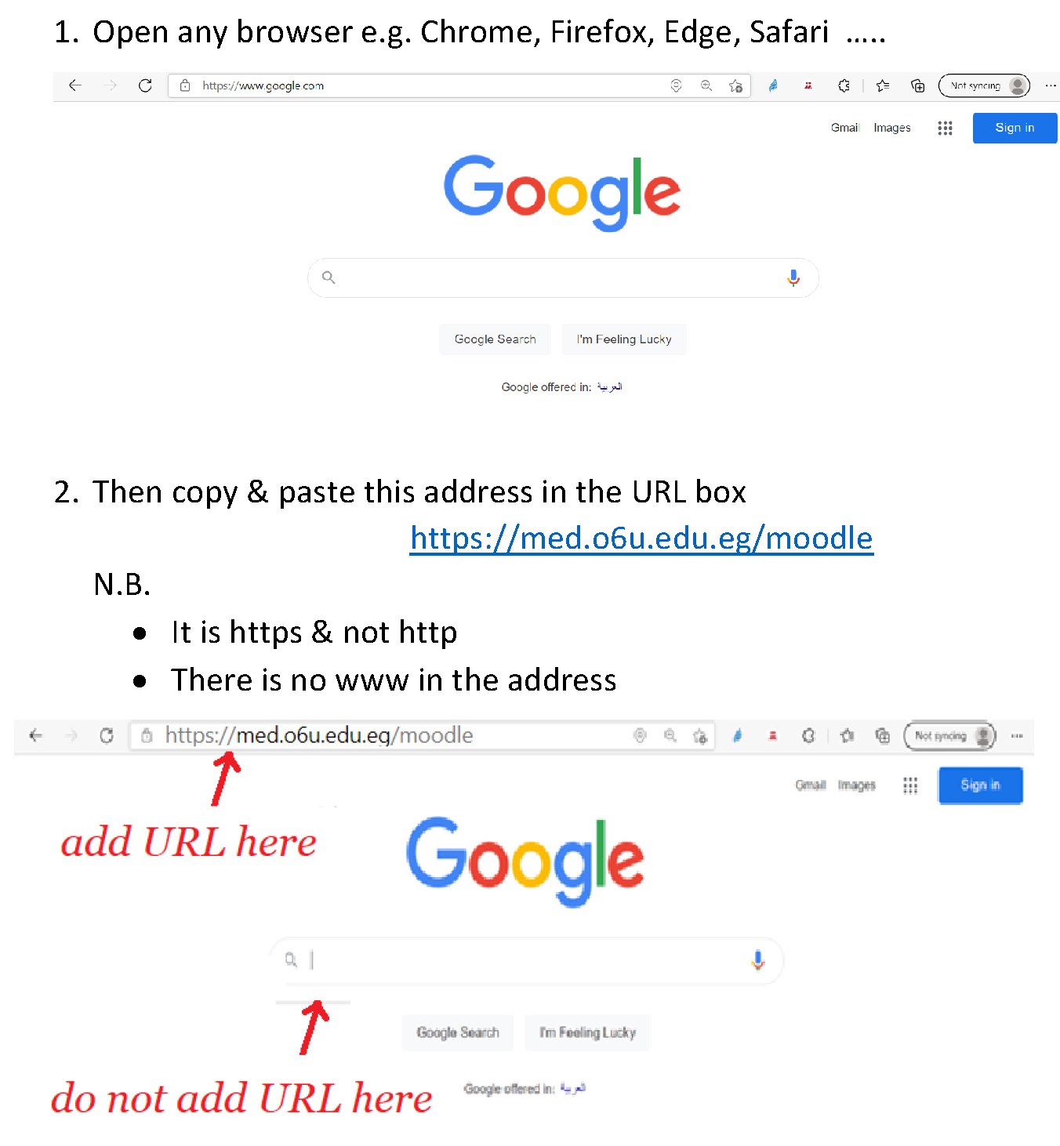
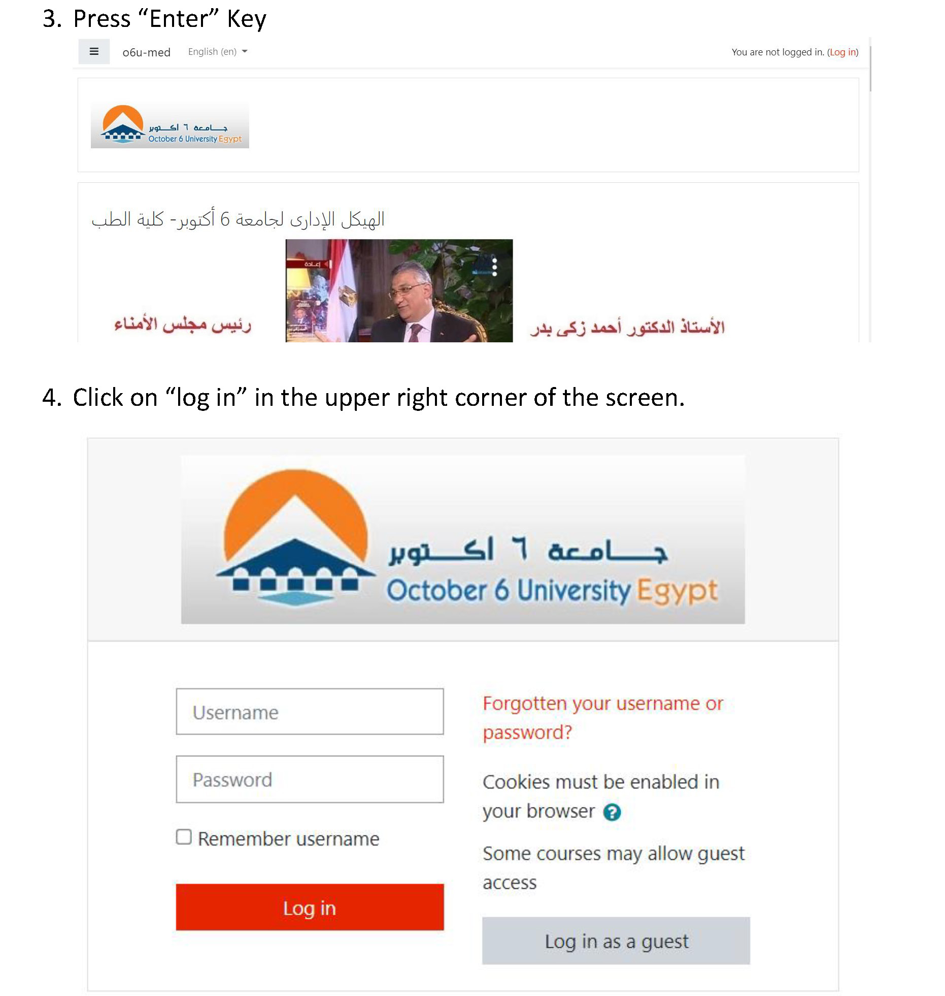
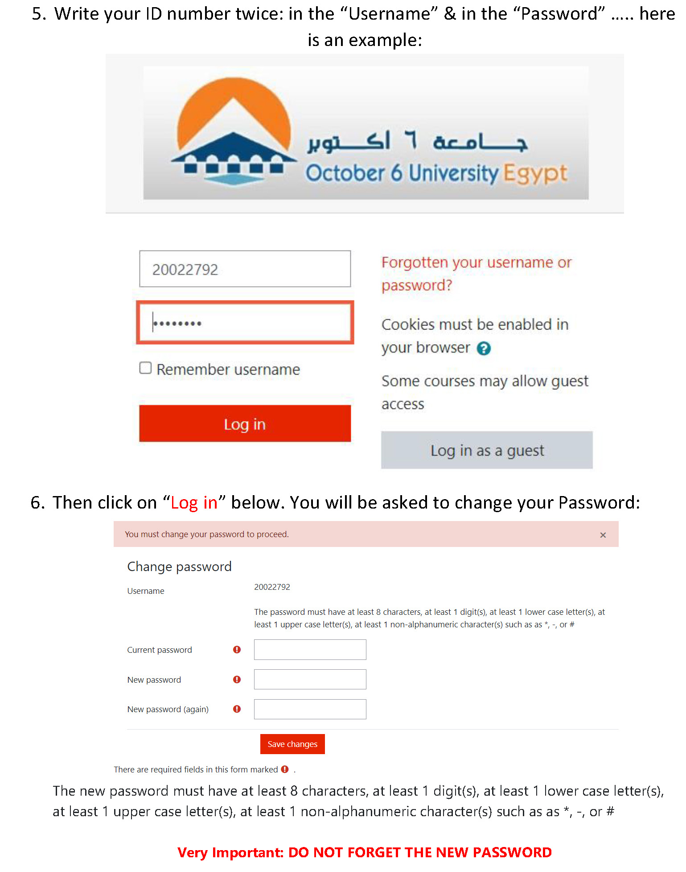
How to enroll yourself in a Module?
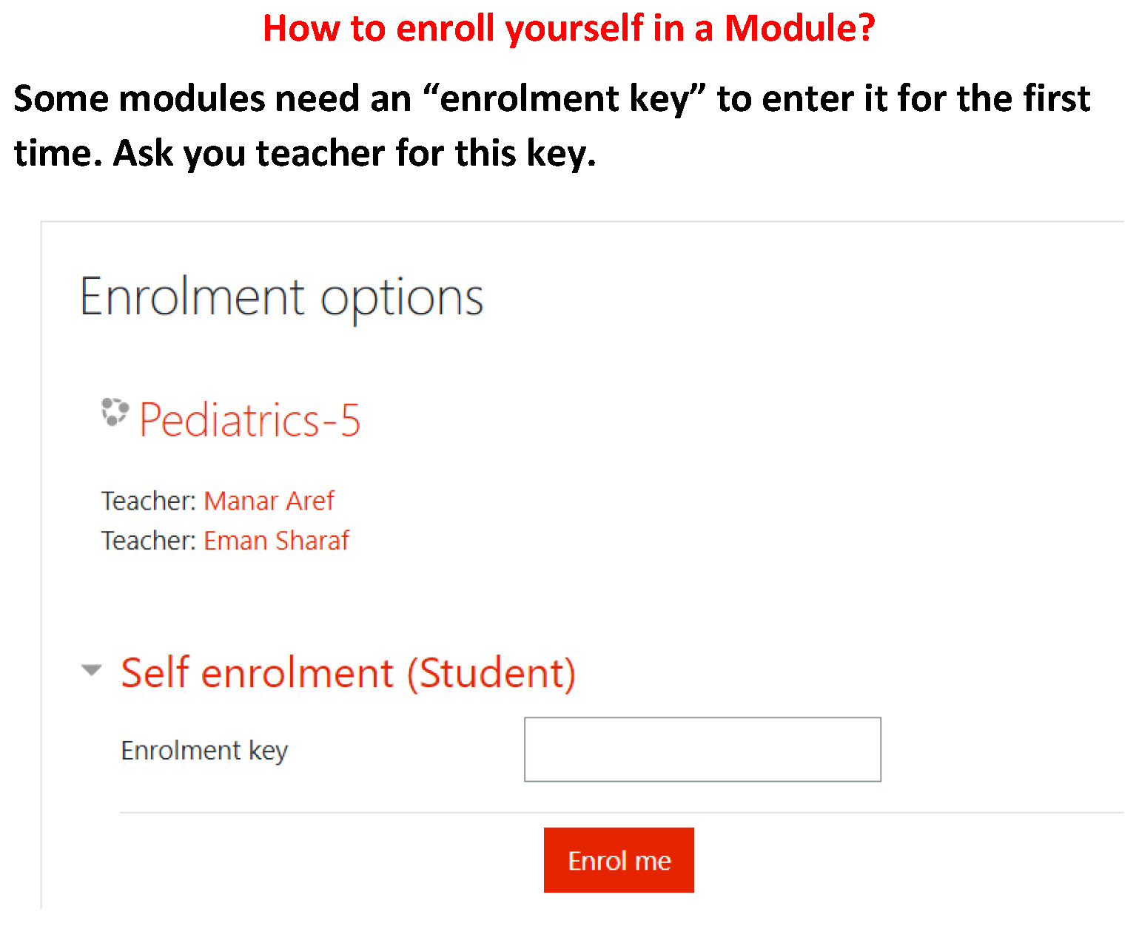
Professional Behavior of student in the case checklist
Students Name: ....................................
Date: ...................................................... End of module (Summative): ...........................
Module title: .....................................................................
Student’s Signature :............................ Tutor’s Name:.....................................................

Criteria | Scale: | Comments
Criteria | 1 and 2 is unsatisfactory,  3, 4 and 5 is satisfactory performance | Comments
Preparation:  Is well prepared with relevant information, uses a variety of references and summarizes key points | 1 2 3 4 5
Critical thinking:  Identifies problem, analyzes problem, suggests possible reasons for the problem, helps group to formulate learning objectives | 1 2 3 4 5
Participation:  Participates actively, talks on turn and listens attentively to others | 1 2 3 4 5
Communication Skill & Group Skills:  Respects tutor and colleagues, communicates well uses appropriate language, accepts feedback and responds appropriately.  Contributes to group learning, shares information with others, demonstrates sensitivity to views and feeling of others, takes on assigned tasks willingly | 1 2 3 4 5
Presentation skills:  Presents the information relevant to the learning objectivse of the case, explains clearly the reasoning process with regard to solving the problem | 1 2 3 4 5
 | SATISFACTORY | UNSATISFACTORY

-The students portfolio (October 6 university - faculty of medicine - 2022 - 2023):
- Each student should go through one of the following links to make his google e-portfolio where he (she) will put the progression he will achieve in each module WEEK BY WEEK and e will send the link to the tutor to revise it. SENDING BY MAIL TO THE TUTOR IS ACCEPTED BUT PAPER WORK IS NOT ACCEPTED
- Links to make e-portfolio using google sites
https://www.google.com/url?sa=t&rct=j&q=&esrc=s&source=web&cd=&cad=rja&uact=8&ved=2ahUKEwi9xOnhrYDzAhVERkEAHb_0DCgQFnoECC0QAQ&url=https%3A%2F%2Fwww.montclair.edu%2Fmedia%2Fmontclairedu%2Foit%2Fdocumentation%2Feportfolios%2FGoogle-Sites-ePortfolio-3-13-PF-Final.pdf&usg=AOvVaw2PTNDhBjsWkTV75RJGCoen

https://www.google.com/url?sa=t&rct=j&q=&esrc=s&source=web&cd=&cad=rja&uact=8&ved=2ahUKEwi9xOnhrYDzAhVERkEAHb_0DCgQFnoECC8QAQ&url=https%3A%2F%2Fshakeuplearning.com%2Fblog%2Fhow-to-create-powerful-student-eportfolios-with-google-sites%2F&usg=AOvVaw0koWnu2boD4ufVDvE_jtdo
- The student portfolio should contain the followings:
- Paragraph that summarizes his learning experience and contain the followings in short:
- Resume of him
- Impact made by the education on him
- His present strengths
- His present weakness
- Future suggestions & goals
- Any community medical work the student completed under supervision of a staff presenting the followings:
- Name of staff & position
- Date
- Site
- Results
- Obstacles
- His cases , objectives he got by brain storming , presentations done by him , ( power point )
- Medical pics & posters done by him or his group if present
- Web page , or brouchure constructed by him or his group if present
- Conferences attended by him if present
- Visits done to clinical departments to see relevant experiments studied
- Two to three education events attended by him
- Two to three meetings with educational or clinical supervisors
- Get started with scopus
- Students should collect the presentations the group will do along the sessions of the cases and put them in the binder of the portfolio, with the cases , CV and the needed assignments , prochures , or links for the channels as will be announced

BONUS MARKS ADDED TO THE PORTFOLIO MARK ONLY IF NEEDED
- If any student shared in a paper with any of the staff
-If any student constructed cases on sectra table
-If any student shared the activities of the quality unit
-If any student shared in the electronic evaluations
- Portfolio scoring (Rubrics for evaluating portfolios):
- Each student should be rated as one of the followings :
- Out standing & he will be given 95% to 100% of the portfolio mark
- Acceptable & he will be given 70% to 75% of the portfolio mark
- Marginal & he will be given 60% to 65% of the portfolio mark
- Unacceptable & he will be given less than 60% of the portfolio mark

OSPE , OSCE, DOCEE | End module | Continuous assessment | Mid module | FIFTH YEAR
38 marks total  -slides electronic  -OSCE  -DOCEE | 50 marks total  40 MCQ  10 SAQs electronic | 10 marks total  1.5 attendance sections  1.5 attendance cases  4 presentation  3 portfolio | 27 marks electronic | GYGYN 506  12125 marks
38 marks total  -slides electronic  -OSCE  -DOCEE | 50 marks total  40 MCQ  10 SAQs electronic | 10 marks total  1.5 attendance small groups  1.5 attendance cases  4 presentation  3 portfolio | 27 marks electronic | SMSM 507  DeDermatology anand andrology  12125 marks
45 marks total  -slides electronic  -OSCE  -DOCEE | 60 marks total  50 MCQ  10 SAQs electronic | 10 marks total  1.5 attendance sections  1.5 attendance cases  4 presentation  3 portfolio | 35 marks electronic | SMSM 508  BloBlood and vaVascular  15150
 | 50 marks total  40 MCQ |  |  | SMSM 509  O Obesity  50 50 marks

Cases for the fifth year students (Second term 2023-2024)
GYN 506 :
CASE ONE
CASE 1: A 32-year-old nulligravida complains of pelvic pain for 7 months and delayed conception for 2 years. The pain is exacerbated during menstruation. She confirms severe pain during sexual intercourse. She declines a current or previous history of abnormal vaginal discharge. she has a pelvic trans vaginal ultrasound scan (TVUSS), as part of investigations for primary subfertility. The scan shows bilateral 5 cm ‘kissing’ ovarian cysts in the pouch of Douglas (POD), both of which contain diffuse, low-level echoes giving a solid ‘ground-glass’ appearance.
Objectives

CASE TWO :

A 34-year-old nulligravida presents with increasingly heavy menstrual periods and an abdominal swelling. Bimanual examination revealed a pelvic firm mass. She is due to get married next month and plans to start a family soon. Several hormonal and non-hormonal medical treatments prescribed by her gynecologist for the heavy menstrual bleeding (HMB) have failed in the past 5 years.

Objectives

SM 507 Dermatology and Andrology
Case ONE:
A 60-year-old man presented to the dermatology clinic in October 6 university hospital with a recurring back rash. He reported that the complain occur most often during the summer. The condition was treated successfully with an antifungal shampoo as prescribed by his neighbor dermatologist. The rash is not itchy or painful. He reported a history of depression and hypertension. On physical examination, hyperpigmented macules coalescing into patches with very fine white scale are found. The lesions are scattered on his upper chest and upper back.
Objectives

Case TWO:
A 17-year-old Black man presents with a one-year history of spots on his back. The was slowly growing, with several new lesions appearing near the first one. It is not itchy or painful. He has not try any medications. He has no relevant medical history and none of his family members have similar skin findings. On examination, there are several well-demarcated depigmented macules and patches on his lateral back.
Objectives

Case THREE:
A 55-year-old woman with a history of depression presents to the dermatology clinic with a one-year history of intermittent rash. She was hospitalized for COVID-19 approximately one year ago and soon after developed a rash all over her body. The lesions persist for several days and have a burning sensation. The patient has no associated joint pain or other systemic symptoms. She tried antihistamines for the rash with no symptomatic relief. On examination, erythematous wheals are evident on her arms and legs as well as her back and abdomen.
Objectives

SM 508 Blood and vascular
CASE ONE :
CASE STUDY. LYMPHADENOPATHY

Case:
A 18 years old female patient presented with easy fatiguability, shortness of breath , bleeding gums and fever.
The symptoms started few weeks ago and the course is progressive. She noticed few lumps in her neck.
Examination revealed pallor, bleeding gums and temperature of 38° C.
There was lymphadenopathy affecting cervical group, axillary group, and inguinal group.
Abdominal examination revealed hepatomegaly and splenomegaly.
Laboratory studies revealed total white cell count of 50,000 and platelet count of 30,000 and Hemoglobin level of 9.
What is your diagnosis?
What is the differential diagnosis?
How to investigate such a case?
Objectives:

SM 509 Obesity weeks
A 49-year-old woman presented to the clinic for follow up with hypothyroidism and osteoarthritis of the right knee. She reported that she is trying to lose weight as advised by the orthopedic surgery surgeon to be prepared for right knee surgery. The weight loss has plateaued on a low-calorie meal plan. Her exercise is limited by chronic knee pain. She tracks her calories and daily steps. After the discussion about the risks and benefits of weight loss medications, she was started on phentermine/topiramate extended-release daily. She returns three months later and has lost 3% of her body weight since the last visit. On physical examination, her BMI is 34 kg/m². She has decreased range of motion of right knee. Otherwise, the physical examination is unremarkable.
OBJECTIVES

CASE TWO:
A 63-year-old African American male with a history of obesity, T2DM, CKD3b and recent NSTEMI was referred for cardiometabolic risk optimization.
Medications: atorvastatin 80mg, lisinopril 20mg, aspirin 162mg, metformin 1000mg bid, metoprolol 50mg daily, duloxetine 20mg daily
Diet:
- Heavy in starchy and refined carbohydrates, “meat & potatoes,” and casseroles
- Doesn’t snack much and avoids sweets or baked goods during the day and evening but eats fruit for dessert
- No sugar-sweetened beverages and rare alcohol
Exercise: states he has always been physically active with his work but has been in cardiac rehab three times weekly for the past 6 weeks
Sleep: has OSA treated with cpap
Exam: BMI 37 and waist circumference 111cm; BP 140/90; pulse 66
Labs: HbA1c 7.6%, eGFR 44, total cholesterol 145, HDLc 45 mg/dL, trig 160 mg/dL, LDLc 68 mg/dL, albumin 4, ALT 35, platelets 300,000, urine albumin:creatinine 320
OBJECTIVES :

